Unpacking Marijuana's Effect on Violent Crime
Nicholas Ricci
12/2/2024
Econometrics: Causal Inference, Panel and Survey Data(FA 2024_ECO4422.01 I&T)

Abstract
The legalization of medical marijuana (MML) has prompted ongoing debate about its potential effects on violent crime rates. This study examines the relationship between MML and violent crime across U.S. states by comparing key demographic and economic variables from 1990 and 2019, two critical points in marijuana policy evolution. Using directed acyclic graphs (DAGs) to visualize causal pathways, the analysis employs robust techniques such as propensity score matching (PSM), inverse probability weighted regression adjustment (IPWRA), and randomization inference to assess the impact of MML on violent crime. Confusion matrices and the comparison of multiple treatment and outcome models further ensure the reliability of the results. Findings suggest that while marijuana legalization may influence violent crime rates, the results are not consistent across all methods, indicating that further research is needed. This study contributes to the broader understanding of marijuana policy’s impact on crime and provides valuable insights for policymakers, emphasizing the need to consider socio-economic factors and potential long-term effects when designing marijuana-related policies.

Introduction
The legalization of marijuana for medical use (Medical Marijuana Legalization, or MML) has sparked significant debate regarding its potential societal consequences, particularly with respect to violent crime rates. Proponents argue that MML could reduce violent crime by providing a regulated alternative to illegal drug markets and addressing socio-economic stressors that often contribute to crime. On the other hand, critics worry that the increased availability of marijuana could impair judgment or exacerbate social problems, potentially leading to an uptick in violence.
This study aims to explore the relationship between MML and violent crime rates across U.S. states by comparing key variables from two distinct time periods: 1990 and 2019. These years were chosen to capture a critical transition in marijuana policy and its potential impact on crime. In 1990, marijuana was largely illegal, and drug policies were dominated by the "War on Drugs" framework, which contributed to strict enforcement and punitive measures. By 2019, medical marijuana had been legalized in numerous states, signaling a shift in both public attitudes and drug policy. This transition provides a unique opportunity to examine how MML may have influenced violent crime over time, considering both direct and indirect effects of policy change.
The study focuses on key variables that capture demographic, economic, and policy-related factors likely to influence crime rates, including: state population size (pop), median age (age), median household income (med_household), poverty rates (poverty_rates), and violent crime rates (violent1990, violent2019). These variables are used to assess how changes in marijuana policy might relate to shifts in violent crime, controlling for socio-economic and demographic factors that are known to affect crime dynamics. The analysis specifically compares the impact of these variables between 1990 and 2019 to identify any significant shifts or trends linked to marijuana policy changes.
To assess the causal relationship between MML and violent crime rates, the study employs several robust analytical techniques, including Directed Acyclic Graphs (DAGs), which are used to visualize and conceptualize the potential causal pathways between variables. The DAG framework helps identify key relationships, such as how socio-economic factors like poverty rates or median household income might indirectly influence violent crime through mechanisms like resource availability or social stress.
The study utilizes Propensity Score Matching (PSM) to create comparable groups of states with and without medical marijuana legalization, accounting for key demographic and economic similarities. PSM helps reduce selection bias by matching treated (legalized) and control (non-legalized) states based on similar characteristics, making it possible to isolate the impact of marijuana legalization on violent crime rates. This is complemented by Inverse Probability Weighted Regression Adjustment (IPWRA), which combines the benefits of propensity score weighting with regression adjustment to further reduce bias and improve treatment effect estimates.
In addition to PSM and IPWRA, confusion matrices are used to evaluate the performance of various treatment and outcome models, helping to assess how well the models classify states as being influenced by MML policies. The study compares multiple treatment and outcome models to ensure that the conclusions drawn are consistent across different methodological approaches, providing a more reliable and robust understanding of marijuana’s effects on violent crime.
Finally, randomization inference is applied to test the statistical significance of the findings. This non-parametric approach simulates the random assignment of marijuana legalization across states, comparing observed effects to placebo distributions to strengthen the credibility of the results. Randomization inference accounts for potential dependencies between observations, enhancing the rigor of the statistical analysis.
By integrating these diverse methodologies, the study aims to provide a comprehensive assessment of how medical marijuana legalization has impacted violent crime rates, comparing data from 1990 and 2019. The results will offer valuable insights for policymakers considering marijuana legalization, highlighting not only direct effects on crime but also the broader socio-economic context in which these policies are implemented. Through this rigorous, multi-method approach, the study seeks to contribute to the ongoing debate over the societal consequences of marijuana use and its regulation.
Literature Review
The relationship between marijuana legalization and violent crime has been a topic of extensive research, with a shift in findings as marijuana laws have evolved. Early studies largely supported the notion that marijuana was linked to crime and violence. However, more recent research has suggested that marijuana legalization, particularly medical marijuana, may have little to no effect on violent crime or, in some cases, even reduce crime rates. This review examines key studies that explore these connections, focusing on both medical and recreational marijuana legalization.
Dragone et al. (2019) provide an important contribution to the literature by examining the impact of recreational marijuana legalization in Washington and Oregon. Using differences-in-differences and spatial regression discontinuity designs, the authors found that legalization led to a reduction in crime. They argued that marijuana use, which tends to induce relaxation, reduces the likelihood of violent behavior. The study also highlighted that marijuana could substitute for alcohol, a substance often associated with violent crimes. Furthermore, the legalization of marijuana allowed law enforcement to redirect efforts away from marijuana-related offenses, reducing overall criminal activity. While promising, the study's short four-year timeline and limited scope make it difficult to generalize these findings across the U.S.
Chu and Townsend (2018) conducted a broader analysis that explored the effects of medical marijuana legalization across multiple levels—city, state, and national. Their study, which employed regression analysis and synthetic control methods, found no causal relationship between medical marijuana laws and violent crime at the national level or within individual states. However, they did observe a 20% reduction in both violent and property crimes in California, where medical marijuana laws were implemented earlier. This finding underscores the potential localized effects of medical marijuana laws but leaves open the question of how recreational marijuana legalization might affect crime rates, which they did not address.
Morris et al. (2014) also investigated the relationship between medical marijuana laws and crime, utilizing state panel data from 1990 to 2006. Their analysis found no evidence of a crime-exacerbating effect following the legalization of medical marijuana, and they even observed a potential reduction in homicide and assault rates. Although this study adds to the growing body of literature suggesting that marijuana legalization may not lead to increased crime, its limited time frame—ending before the legalization of recreational marijuana—reduces the comprehensiveness of the findings.
Brinkman and Mok-Lamme (2017) and Chang and Jacobson (2017) each examined the effects of marijuana dispensaries on local crime rates. Brinkman and Mok-Lamme’s study, conducted in Denver, Colorado, found that retail dispensaries led to reduced crime in the neighborhoods where they were located, though there were no spillover effects to adjacent areas. Similarly, Chang and Jacobson (2017) looked at the effects of dispensary closures in Los Angeles and found that crime increased following these closures. Both studies contribute valuable insights into the localized impacts of marijuana legalization but are limited by their narrow geographical and temporal scopes.
Overall, while studies like those by Dragone et al. (2019) and Chu and Townsend (2018) suggest that marijuana legalization may reduce crime, the existing body of research remains inconclusive. The complexity of the issue is reflected in studies like Morris et al. (2014), which found no significant effect of medical marijuana laws on crime, and Brinkman and Mok-Lamme (2017), which highlighted the localized effects of dispensaries. As marijuana laws continue to evolve, further research is needed to determine the broader implications of legalization on violent crime rates.
Data and Methods
The analysis investigates the effects of marijuana legalization on violent crime rates by examining key variables from 1990, reflecting marijuana use, and 2019, reflecting violent crime rates. Each pair of variables from these years—violent crime rates, population, median age, poverty rates, and median household income—was obtained from the same source. The data were transformed into natural logarithmic form to ensure proportional scaling and reduce skewness. These transformations allowed for robust comparisons across states and over time.
Violent crime rates for 1990 and 2019 were sourced from the State Crime dataset in the CORGIS library, which uses data originally collected through the FBI's Uniform Crime Reporting (UCR) system. The violent crime rate is defined as the number of violent crimes per 100,000 residents and includes offenses such as homicide, robbery, and aggravated assault. This variable captures the prevalence of violent crime and allows for a comparative analysis of crime levels before and after the observed effects of marijuana legalization.
Population data for 1990 and 2019 were sourced from the State Crime dataset in the CORGIS library, which compiles its data from the FBI’s Uniform Crime Reporting (UCR) system. This dataset provides comprehensive population data for each state, offering essential context for interpreting crime rates on a per capita basis. Population size is a crucial variable in criminology, as it enables the adjustment of crime rates to reflect state size and density, helping to account for differences in crime rates between smaller and larger states. Including population data for both 1990 and 2019 ensures that any observed trends in violent crime are not confounded by changes in state populations, offering a clearer, more proportional view of crime dynamics over time. By considering this information, the analysis can more accurately assess the relationship between marijuana policy changes and shifts in violent crime, while controlling for population growth or decline in each state.
Median age data for 1990 and 2019 were sourced from U.S. Census Bureau reports. The 1990 data were extracted from the archived dataset Median Age by State, 1990–2000, while the 2019 data were manually obtained from the Census Bureau’s State Population Estimates for the 2010s. The median age is an important demographic indicator that reflects the age distribution within a state. Age composition can influence crime rates, as younger populations, typically between 18 and 34 years old, tend to be more involved in violent crime, while older populations may exhibit lower crime rates. Therefore, shifts in the median age between 1990 and 2019 can provide valuable insight into the broader socio-demographic trends that might influence crime, independent of marijuana policy changes. For example, a state with a growing elderly population may experience lower crime rates over time, regardless of marijuana legalization, while a state with a growing youth population may see an increase in crime, potentially complicating the interpretation of crime trends.
Median household income data for both 1990 and 2019 were obtained from the U.S. Census Bureau’s historical income tables, specifically Table H-8: Median Household Income by State. Household income is a well-established indicator of economic well-being and financial stability. It serves as a proxy for broader socio-economic conditions within each state, which can play a significant role in shaping crime rates. States with higher median household incomes typically experience lower crime rates, as financial stability can reduce economic pressures that often contribute to criminal behavior. Conversely, lower-income states or those with widening income inequality may see higher rates of violent crime, as poverty and lack of opportunity are often linked to criminal activity. By comparing income levels from 1990 and 2019, the analysis accounts for economic trends that could either support or complicate the observed effects of medical marijuana legalization on crime rates.
Poverty rate data for 1990 and 2019 were sourced from a dataset provided by Statistics and Data, which tracks state-level poverty rates over time. Poverty is defined as the percentage of individuals living below the federal poverty line, and it serves as a critical indicator of socio-economic inequality within each state. Poverty is strongly correlated with violent crime, as financial hardship can lead to frustration, social disintegration, and an increased likelihood of individuals engaging in criminal behavior as a means of survival or protest. By including poverty rates from both 1990 and 2019, the study captures shifts in economic disparity that may be contributing to changes in violent crime rates. For instance, a state that has experienced an increase in poverty over the past few decades may see a rise in violent crime, regardless of changes in marijuana policy. This underscores the importance of controlling for poverty when examining the potential effects of marijuana legalization on crime.
For all of the above variables—population size, median age, median household income, and poverty rates—a natural logarithmic transformation was applied. This transformation is commonly used in econometric analysis to normalize skewed data, reducing the impact of extreme outliers and enabling a more accurate modeling of relationships between variables. Applying a natural log transformation also facilitates the interpretation of coefficients in the model, as it converts multiplicative effects into additive ones. This means that the analysis can more easily capture proportional changes, offering a clearer picture of how variations in one variable, such as income or population, influence crime rates relative to changes in other variables. By applying this transformation consistently across all data points from 1990 and 2019, the study ensures that it is comparing like-for-like values, allowing for a more robust and interpretable analysis of the long-term effects of marijuana use and policy changes on violent crime rates.
The careful selection of these key demographic and economic variables, alongside the consistent application of data transformations, ensures that the study integrates both the treatment model from 1990 and the outcome model from 2019 in a coherent and meaningful way. By adjusting for population size, economic conditions, and other socio-demographic factors, the analysis seeks to isolate the impact of medical marijuana legalization on violent crime, providing policymakers and researchers with valuable insights into the potential consequences of marijuana policy changes.
Summary Statistics
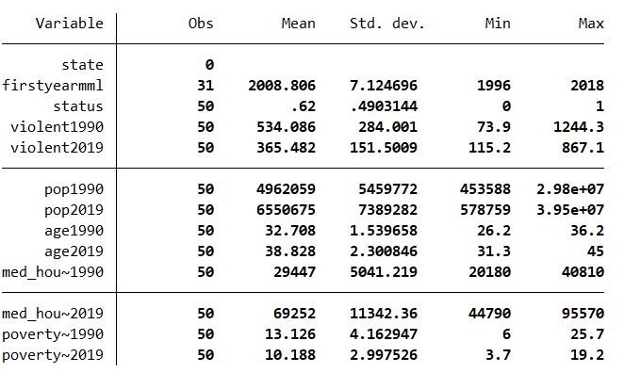
Table 1: Summary Statistics for All Variables
Data Visualizations
The following line graphs below were created using data from an Excel file, analyzing variables such as violent crime rates, population, median age, household income, and poverty rates across all 50 states. Although the graphs lack a detailed key to distinguish individual states, they aim to provide a general overview of trends from 1990 to 2019. Despite the somewhat messy depiction caused by the sheer number of states included, the graphs effectively illustrate the overall shifts in these variables over time, offering a broad understanding of the changes that occurred across the nation.
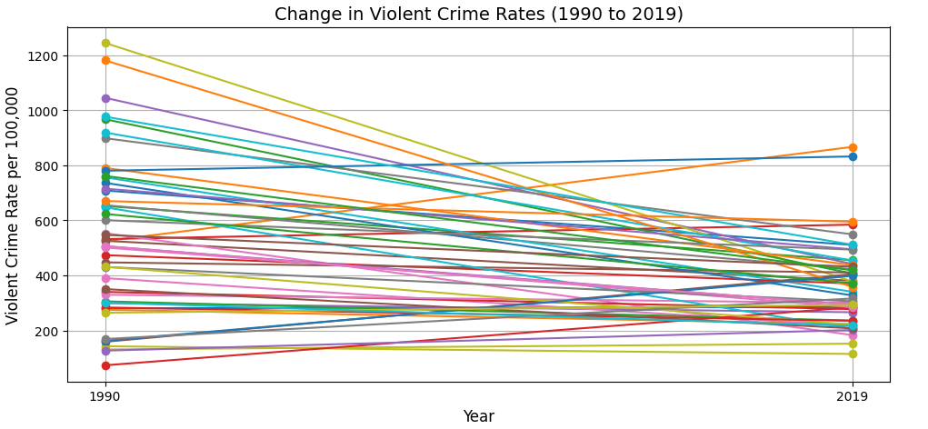
Figure 1: Line Graph of the Change in Violent Crime Rates from Year 1990 to Year 2019 For All States

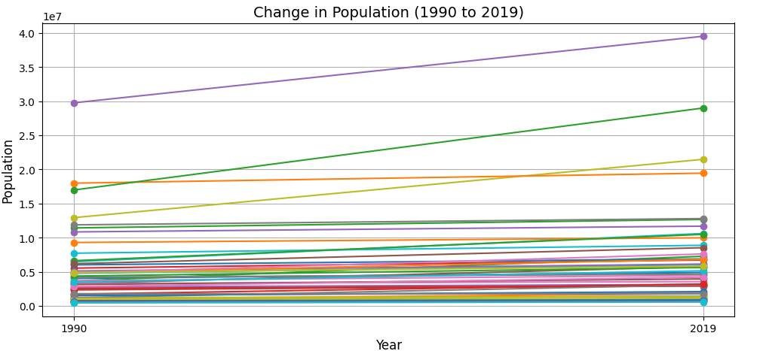
Figure 2: Line Graph of the Change in Population Density from Year 1990 to Year 2019 For All States

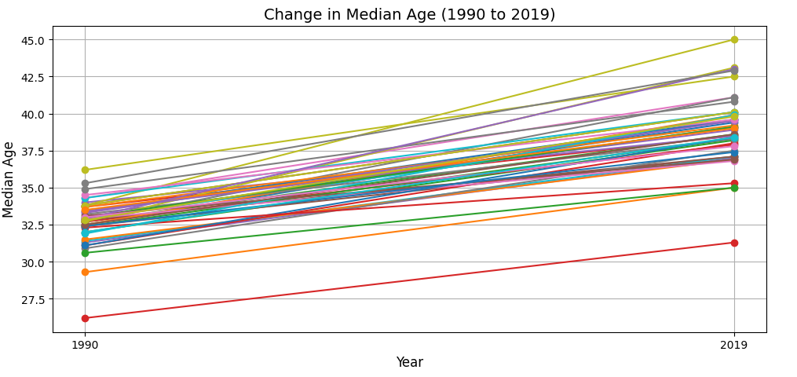
Figure 3: Line Graph of the Change in Median Age from Year 1990 to Year 2019 For All States
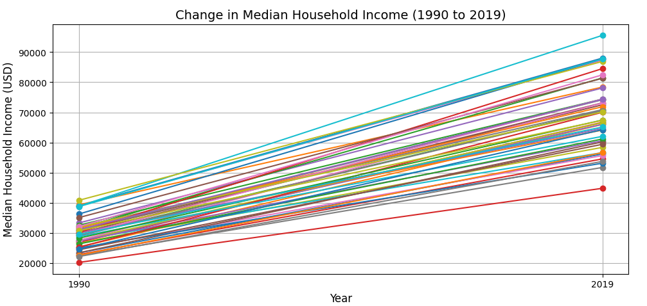
Figure 4: Line Graph of the Change in Median Household Income from Year 1990 to Year 2019 For All States

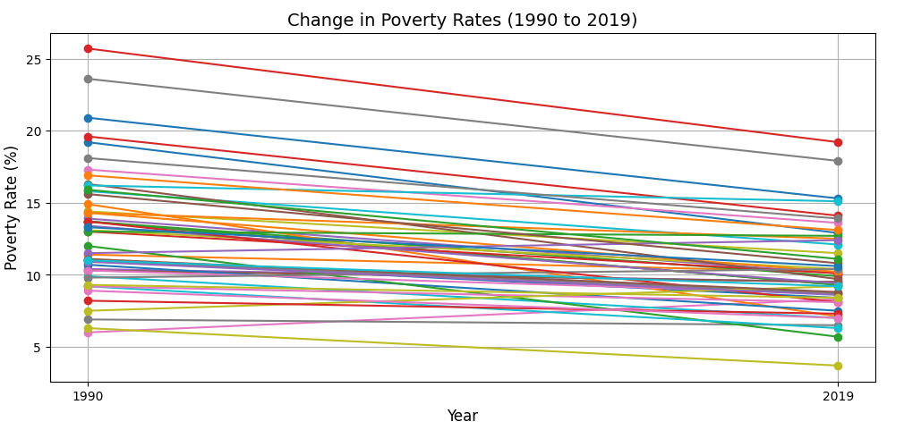
Figure 5: Line Graph of the Change in Poverty Rates from Year 1990 to Year 2019 For All States
Justification of Methods and Variable Selection/Exclusion
The variables used in this analysis were carefully selected based on their relevance to treatment receipt and outcomes, their theoretical importance in explaining socio-economic dynamics, and the availability of data across both 1990 and 2019 time periods. Violent crime rates (violent1990 and violent2019) were included because they are often indicative of social instability, which can influence both the need for and the effectiveness of treatment interventions. The comparison of these rates over time provided insights into how shifts in social conditions might have affected treatment dynamics. Population size (pop1990 and pop2019) was another key variable, as it directly impacts the demand for treatment services. Larger populations often create more competition for resources, which can influence the prioritization of treatment programs. Tracking population size over time allowed for an understanding of how changing demographic conditions might have influenced treatment receipt.
Median age (age1990 and age2019) was included because age distribution significantly affects the need for treatment, with older populations often requiring different services. The changes in median age over time provided important context for understanding shifts in treatment needs. Median household income (med_household1990 and med_household2019) and poverty rates (poverty_rates1990 and poverty_rates2019) were also critical variables, as economic hardship is closely tied to access to healthcare and social services. These variables helped to control for socio-economic disparities that may have influenced both treatment eligibility and outcomes, allowing for a clearer understanding of treatment dynamics across different economic conditions. Notably, poverty rates were chosen over unemployment rates as a more accurate reflection of economic hardship. While unemployment rates capture the proportion of the labor force without work, poverty rates provide a more comprehensive picture of overall economic deprivation, accounting for individuals who are employed but still live below the poverty line. Given that treatment interventions often target individuals in economic distress, poverty rates offered a more direct and accurate measure of the populations that might benefit from these programs.
Religious fundamentalism and voter party registration were considered but ultimately excluded from the analysis. The decision to exclude these variables was largely due to the lack of sufficient and detailed information in the sources reviewed. Specifically, the sources did not provide a clear link between religious fundamentalism and treatment receipt or outcomes, nor did they discuss voter party registration in a way that would justify its inclusion as a significant explanatory variable. Religious fundamentalism, in particular, was not adequately addressed in the literature, and its relevance to treatment dynamics was not well established. Similarly, party affiliation and political registration were not discussed in depth in relation to treatment, and including such data would have introduced uncertainty into the analysis due to the context-specific nature of political variables. Therefore, these variables were excluded in favor of those that provided a stronger empirical and theoretical foundation for explaining the treatment effect.
Other variables, such as drug-related crime rates (other drugs), cannabis dispensary density, and state policy on alcohol and tobacco regulation, were also considered but excluded due to their weak theoretical relevance and potential to introduce problems in the model, such as overfitting or multi-collinearity. While these variables might provide some insight into substance-related issues, they were not strongly linked to the treatment outcomes being studied, and their inclusion could have confused the analysis. In particular, drug-related crime rates and cannabis dispensary density might be highly correlated with other socio-economic variables, leading to redundant information and potentially distorting the model’s ability to isolate the true effect of the treatment. Including such variables would have introduced unnecessary complexity, potentially harming the model's generalizability and leading to unreliable results.
Overall, the chosen variables—violent crime rates, population size, median age, median household income, and poverty rates—were supported by the literature and provided a solid basis for understanding the socio-economic factors influencing treatment receipt and its outcomes. The exclusion of variables like religious fundamentalism, voter party registration, and certain substance-related metrics was justified by the lack of robust and consistent data linking these variables to treatment dynamics in the reviewed sources, as well as concerns about overfitting and multi-collinearity. By focusing on the most relevant and well-supported variables, the analysis aimed to offer a clearer, more reliable picture of the factors that influence treatment effectiveness.

Analysis and Results
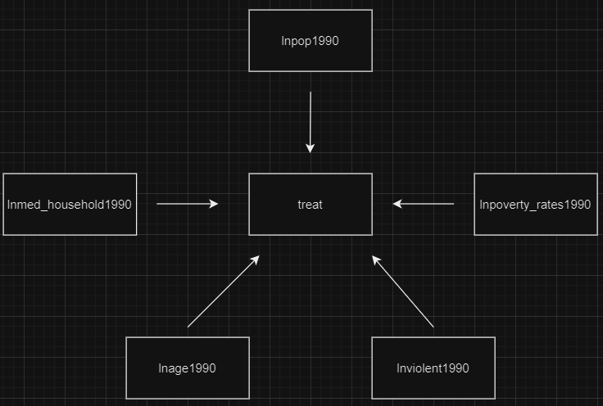
Figure 6: Treatment Model DAG
Treatment Model DAG Variable List
lnviolent1990 = Natural log of violent crime rate in 1990

lnpop1990 = Natural log of population in 1990

lnage1990 = Natural log of median age in 1990

lnpoverty_rates1990 = Natural log of poverty rate in 1990

lnmed_household1990 = Natural log of median household income in 1990

treat = Treatment indicator for marijuana being legalized (1 = legalized, 0 = not legalized)

Treatment Model DAG Explanations Behind Pathways
1. lnviolent1990 → treat: States with a higher violent crime rate in 1990 might be more likely to adopt marijuana legalization policies. Legalizing marijuana could be viewed as a potential way to reduce crime or address illegal drug trafficking and related violence.
2. lnpop1990 → treat: A larger population in 1990 can increase the likelihood of marijuana legalization due to the greater political and economic influence of larger states. Larger states may have more resources or political momentum to pass significant policies like marijuana legalization.
3. lnage1990 → treat: States with a younger or older median age in 1990 may influence marijuana legalization. A younger population may be more open to progressive policies such as marijuana legalization, while an older population may resist due to more conservative views on drug use.
4. lnpoverty_rates1990 → treat: States with higher poverty rates in 1990 may consider marijuana legalization to help alleviate economic struggles through increased tax revenue from the marijuana industry. Legalization may also be part of broader social reforms.
5. lnmed_household1990 → treat: States with higher median household incomes in 1990 might be less likely to legalize marijuana if higher income levels correlate with more conservative attitudes toward drug policies. Conversely, states with lower incomes might see legalization as a way to generate economic growth and tax revenue.
Narrative Explaining the Treatment Model
The treatment model DAG (Directed Acyclic Graph) in this study explores the factors influencing the adoption of recreational marijuana legalization policies in U.S. states. The treatment variable, labeled as treat, indicates whether a state legalized recreational marijuana (1 = legalized, 0 = not legalized). By incorporating key predictors from 1990, the model aims to uncover the social, economic, and demographic conditions associated with legalization decisions.
The first variable, lnviolent1990 (natural log of the violent crime rate in 1990), reflects the hypothesis that states with higher violent crime rates may have considered marijuana legalization as a strategy to address crime or reduce illegal drug-related violence. Lnpop1990 (natural log of the population in 1990) highlights the influence of state size, with larger populations potentially increasing the likelihood of legalization due to greater political and economic influence.
Demographic factors, such as lnage1990 (natural log of the median age in 1990), capture the role of population age. States with younger populations may have been more supportive of progressive policies like legalization, whereas older populations might have resisted due to more conservative views on drug policies. Economic considerations also play a central role in the model. Lnpoverty_rates1990 (natural log of the poverty rate in 1990) suggests that states with higher poverty rates may have been motivated to legalize marijuana to generate tax revenue and address economic struggles. Conversely, lnmed_household1990 (natural log of median household income in 1990) examines the influence of economic status, positing that states with higher median incomes may have been less likely to legalize due to more conservative attitudes, while states with lower incomes might have viewed legalization as a means to stimulate economic growth.
This treatment model provides a framework for understanding how social, economic, and demographic factors from 1990 influenced marijuana legalization decisions. It emphasizes how initial conditions such as crime rates, population characteristics, and economic circumstances shaped state-level policy outcomes, offering valuable insights into the broader implications of marijuana legalization.
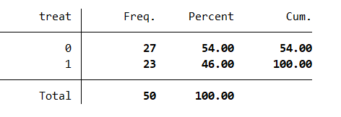
Table 2: Distribution of Treatment Variable for Marijuana Legalization
The following table presents the distribution of the treatment variable, treat, which indicates whether a state legalized marijuana for recreational use before 2015. The treatment variable is coded as 1 for states that legalized recreational marijuana before 2015 (treatment group) and 0 for states that did not legalize it by that year (control group). The tabulate treat command shows that 27 states (54.00% of the sample) belong to the control group, while 23 states (46.00% of the sample) belong to the treatment group. This distribution demonstrates a fairly balanced allocation between the treatment and control groups, with a total of 50 states included in the analysis. The results confirm that the treatment variable was correctly created, providing a reliable foundation for further examination of the factors influencing marijuana legalization.
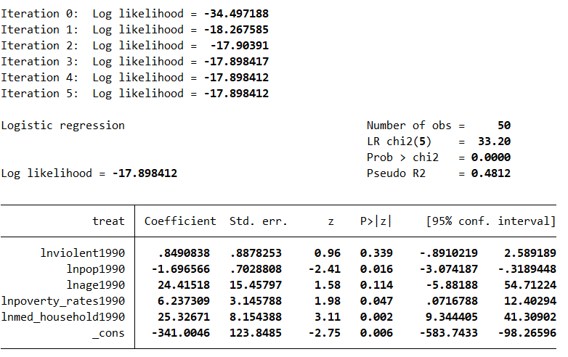
Figure 7: Treatment Model 1 (All Covariates)
Treatment Model 1 uses logistic regression to analyze the relationship between various covariates and the likelihood of receiving the treatment (denoted as "treat"). The model includes five independent variables: the natural log of violent crime rates in 1990 (lnviolent1990), the natural log of population size in 1990 (lnpop1990), the natural log of median age in 1990 (lnage1990), the natural log of poverty rates in 1990 (lnpoverty_rates1990), and the natural log of median household income in 1990 (lnmed_household1990). The dependent variable is the treatment indicator (treat), representing whether a particular state received a certain treatment based on the covariates.
The regression results show that the model is statistically significant, with a likelihood ratio (LR) chi-squared value of 33.20 and a p-value of 0.0000, indicating that the covariates collectively have a strong effect on the treatment variable. The pseudo R-squared value of 0.4812 suggests that the model explains approximately 48% of the variance in the treatment outcome.
Looking at the individual predictors, the natural log of population size in 1990 (lnpop1990) is statistically significant, with a negative coefficient of -1.696566, suggesting that larger populations in 1990 are associated with a lower likelihood of receiving the treatment (p-value = 0.016). The natural log of poverty rates in 1990 (lnpoverty_rates1990) is also significant with a positive coefficient of 6.237309 (p-value = 0.047), indicating that higher poverty rates in 1990 are associated with a higher likelihood of receiving the treatment. Median household income in 1990 (lnmed_household1990) has a strong positive relationship with treatment receipt, with a coefficient of 25.32671 (p-value = 0.002), suggesting that higher median household incomes in 1990 increase the likelihood of receiving the treatment. The other variables, including the natural log of violent crime rates in 1990 (lnviolent1990) and the natural log of median age in 1990 (lnage1990), are not statistically significant at conventional levels, with p-values of 0.339 and 0.114, respectively.
Overall, this first treatment model highlights that socioeconomic factors such as population size, poverty rates, and median household income play significant roles in determining whether a state received the treatment in 1990. However, factors like violent crime rates and median age from 1990 appear to have less influence on treatment receipt in this analysis.
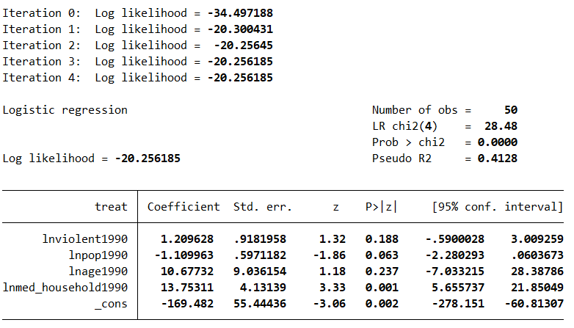
Figure 8: Treatment Model 2 (Excluding Poverty Rates)
Treatment Model 2 is a logistic regression analysis designed to examine the relationship between several covariates and the likelihood of receiving the treatment, excluding poverty rates as a predictor. The independent variables in this model are the natural log of violent crime rates in 1990 (lnviolent1990), the natural log of population size in 1990 (lnpop1990), the natural log of median age in 1990 (lnage1990), and the natural log of median household income in 1990 (lnmed_household1990). The dependent variable is the treatment indicator (treat), indicating whether a state received the treatment.
The results of the model show that it is statistically significant overall, with a likelihood ratio (LR) chi-squared value of 28.48 and a p-value of 0.0000, suggesting that the covariates have a meaningful impact on the likelihood of receiving the treatment. The pseudo R-squared value of 0.4128 indicates that the model explains approximately 41% of the variance in treatment receipt.
Looking at the individual coefficients, the natural log of violent crime rates in 1990 (lnviolent1990) has a positive coefficient of 1.209628, but it is not statistically significant (p-value = 0.188), suggesting that violent crime rates in 1990 do not have a strong influence on treatment receipt in this model. The natural log of population size in 1990 (lnpop1990) has a negative coefficient of -1.109963, and while it is not statistically significant at the 0.05 level (p-value = 0.063), it is close to significance, indicating that larger populations might be associated with a slightly lower likelihood of receiving the treatment.
The natural log of median household income in 1990 (lnmed_household1990) has a positive and statistically significant coefficient of 13.75311 (p-value = 0.001), showing that higher household incomes are associated with a higher likelihood of receiving the treatment. The natural log of median age in 1990 (lnage1990) has a positive coefficient of 10.67732, but it is not statistically significant (p-value = 0.237), indicating that median age does not strongly affect the treatment likelihood.
Overall, this model highlights that median household income is the most significant predictor of treatment receipt, with population size showing a marginal relationship. However, the exclusion of poverty rates results in the other variables, such as violent crime rates and median age, having weaker or insignificant effects on treatment receipt in this analysis.
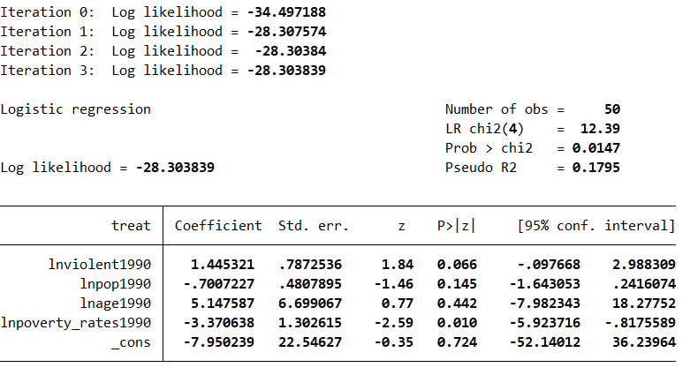
Figure 9: Treatment Model 3 (Excluding Income)
Treatment Model 3 is a logistic regression model that examines the likelihood of marijuana legalization in U.S. states, focusing on socioeconomic and demographic variables from 1990 while excluding median household income. The dependent variable is binary, indicating whether a state legalized marijuana (1) or not (0). The model includes the natural logarithms of violent crime rates in 1990 (lnviolent1990), population size in 1990 (lnpop1990), median age in 1990 (lnage1990), and poverty rates in 1990 (lnpoverty_rates1990) as independent variables.
The overall model is statistically significant, with a likelihood ratio chi-squared value of 12.39 (p = 0.0147), indicating that the included covariates explain some of the variation in the likelihood of marijuana legalization. The pseudo R-squared value of 0.1795 suggests that approximately 18% of the variation in marijuana legalization decisions can be explained by the model.
The coefficient for violent crime rates in 1990 (lnviolent1990) is 1.445321, indicating a positive relationship with the likelihood of legalization, though this result is only marginally significant (p = 0.066). This suggests that while there may be an association between past violent crime rates and the likelihood of marijuana legalization, it is not statistically strong enough to draw firm conclusions. The population size in 1990 (lnpop1990) has a negative coefficient of -0.7007227, suggesting that larger populations were less likely to legalize marijuana, but this result is not statistically significant (p = 0.145), indicating that population size does not have a strong influence in this model.
The coefficient for median age in 1990 (lnage1990) is 5.147587, but this variable is not statistically significant (p = 0.442), suggesting that median age does not have a significant impact on marijuana legalization in the absence of income data. The coefficient for poverty rates in 1990 (lnpoverty_rates1990) is -3.370638, indicating a negative relationship with the likelihood of legalization, which is statistically significant (p = 0.010). This suggests that states with higher poverty rates in 1990 were less likely to have legalized marijuana, possibly reflecting the economic challenges or social conditions that made legalization less viable in those states.
The intercept term (_cons) is -7.950239, which is not statistically significant (p = 0.724), reflecting the baseline log-odds of legalization when all predictors are set to zero.
In summary, Treatment Model 3 indicates that poverty rates in 1990 significantly negatively predicted marijuana legalization, while violent crime rates, population size, and median age did not show strong or consistent effects when median household income was excluded from the analysis. The results suggest that economic factors, particularly poverty, may have played a more significant role in shaping marijuana legalization decisions in these states.

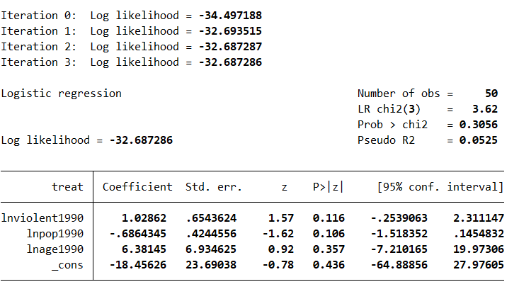
Figure 10: Treatment Model 4 (Excluding Income and Poverty Rates)
Treatment Model 4 is a logistic regression model designed to examine the factors influencing the likelihood of marijuana legalization in U.S. states, with a focus on demographic variables from 1990, excluding median household income and poverty rates. The dependent variable is binary, indicating whether a state legalized marijuana (1) or not (0). The model includes the natural logarithms of violent crime rates in 1990 (lnviolent1990), population size in 1990 (lnpop1990), and median age in 1990 (lnage1990) as independent variables.
The model has a likelihood ratio chi-squared value of 3.62 (p = 0.3056), suggesting that the covariates included in the model do not explain a significant amount of variation in the likelihood of marijuana legalization. The pseudo R-squared value of 0.0525 indicates that only about 5% of the variation in marijuana legalization decisions can be explained by the predictors in this model.
The coefficient for violent crime rates in 1990 (lnviolent1990) is 1.02862, suggesting a positive relationship with the likelihood of legalization, but the result is not statistically significant (p = 0.116). This implies that there is no strong evidence to support the idea that higher violent crime rates in 1990 are associated with a higher likelihood of marijuana legalization in this model. The population size in 1990 (lnpop1990) has a negative coefficient of -0.6864345, indicating that larger populations are less likely to have legalized marijuana. However, this result is also not statistically significant (p = 0.106), meaning that the effect of population size is not conclusive in this analysis.
The coefficient for median age in 1990 (lnage1990) is 6.38145, but this variable is also not statistically significant (p = 0.357), suggesting that median age has little to no impact on marijuana legalization when income and poverty rates are excluded. The intercept term (_cons) is -18.45626, which is not statistically significant (p = 0.436), indicating that the baseline log-odds of legalization, when all predictors are set to zero, are not significantly different from zero.
In summary, Treatment Model 4 indicates that, when excluding income and poverty rates, none of the demographic variables—violent crime rates, population size, or median age—show statistically significant relationships with the likelihood of marijuana legalization. The results suggest that, without the inclusion of income and poverty data, the factors examined here do not sufficiently explain the variation in marijuana legalization decisions across U.S. states.
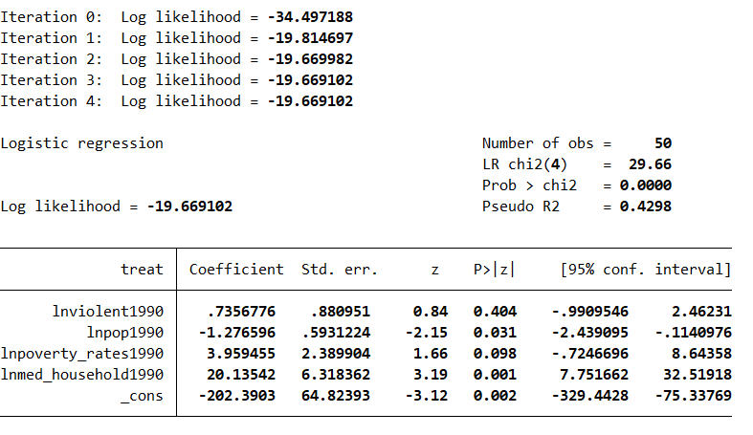
Figure 11: Treatment Model 5 (Excluding Age)
Treatment Model 5 is a logistic regression analysis designed to explore the factors influencing the likelihood of marijuana legalization in U.S. states, excluding the variable for median age. The dependent variable remains binary, indicating whether marijuana was legalized (1) or not (0). The independent variables include the natural logarithms of violent crime rates in 1990 (lnviolent1990), population size in 1990 (lnpop1990), poverty rates in 1990 (lnpoverty_rates1990), and median household income in 1990 (lnmed_household1990).
The model shows a likelihood ratio chi-squared value of 29.66 (p = 0.0000), indicating that the model as a whole is statistically significant. The pseudo R-squared value is 0.4298, suggesting that approximately 43% of the variance in the likelihood of marijuana legalization can be explained by these predictors.
The coefficient for violent crime rates in 1990 (lnviolent1990) is 0.7356776, but this result is not statistically significant (p = 0.404), indicating no strong evidence that violent crime rates are associated with marijuana legalization when age is excluded from the model. The population size in 1990 (lnpop1990) shows a statistically significant negative relationship with marijuana legalization, with a coefficient of -1.276596 (p = 0.031). This suggests that states with larger populations are less likely to legalize marijuana.
The coefficient for poverty rates in 1990 (lnpoverty_rates1990) is 3.959455, with a p-value of 0.098, which is marginally significant at the 10% level. This indicates that higher poverty rates may be associated with a greater likelihood of legalization, though the evidence is not as strong as other predictors in the model. The coefficient for median household income in 1990 (lnmed_household1990) is 20.13542, which is statistically significant (p = 0.001). This suggests a positive relationship between higher median household income and the likelihood of marijuana legalization.
The intercept term (_cons) is -202.3903, which is statistically significant (p = 0.002), indicating that the baseline log-odds of legalization, when all predictors are set to zero, are significantly negative.
In summary, Treatment Model 5 finds that, after excluding median age, larger population size is associated with a lower likelihood of marijuana legalization, while higher median household income is positively associated with legalization. Poverty rates show a marginally significant positive relationship with legalization, while violent crime rates do not have a statistically significant effect in this model. The results suggest that socio-economic factors such as population size and income may play a more substantial role in influencing marijuana legalization decisions than crime rates or poverty alone.
Interpretation of the Best Treatment Model
Based on the results from the five treatment models, Treatment Model 1 (All Covariates) appears to be the best model overall. This model includes a broad range of variables—violent crime rates, population size, median age, poverty rates, and median household income—and demonstrates strong statistical significance with an LR chi-squared value of 33.20 and a p-value of 0.0000. The pseudo R-squared value of 0.4812 suggests that it explains a substantial portion (48%) of the variation in the likelihood of receiving the treatment, which is a relatively high level of explanatory power for a logistic regression model.
While some individual variables (such as violent crime rates and median age) are not statistically significant, key predictors like population size, poverty rates, and median household income have strong, significant effects on treatment receipt. Specifically, median household income shows a particularly strong positive relationship with treatment receipt, and poverty rates also have a meaningful effect.
In comparison, Models 2 through 5 either have weaker explanatory power or result in less statistically significant findings, especially when important variables like income or poverty rates are excluded. Model 1 strikes the best balance by considering all the relevant socio-economic factors that are likely to influence treatment allocation, making it the most robust model.
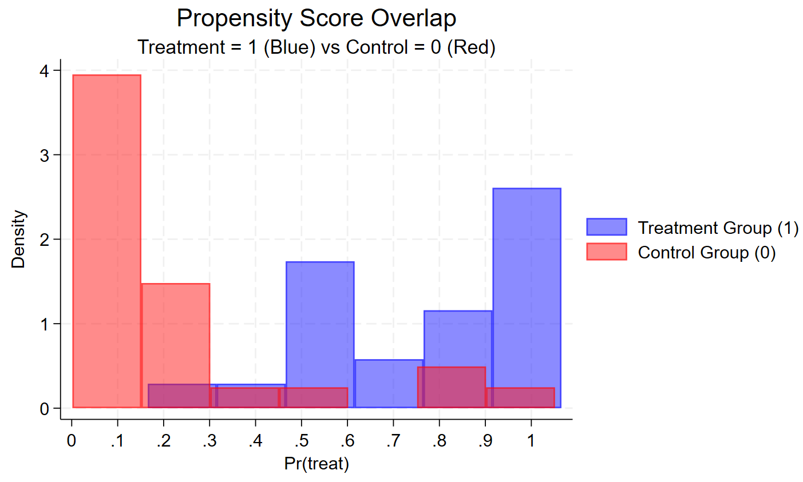
Figure 12: Overlap of Propensity Scores Between Treatment and Control Groups
The figure reveals that while there is generally limited overlap between the treatment and control groups in terms of their propensity scores, there are some regions where the two distributions intersect, which is essential for making valid comparisons. The most notable overlap occurs between the propensity scores of 0.17 and 0.46, representing the primary region of common support between the two groups. This overlap suggests that for individuals with propensity scores in this range, there is a better opportunity to compare treated and untreated units, as they share more similar baseline characteristics. This region offers the most substantial area where matched comparisons could be made with reasonable confidence.
Additionally, a smaller region of overlap exists between the propensity scores of 0.47 and 0.60. While this overlap is less pronounced, it still suggests that a few treated and untreated units within this range may be comparable, though the extent of the overlap is more limited than the primary region. Finally, a very small amount of overlap is observed from 0.74 to 1, where a few treated and control units share similar propensity scores. However, this overlap is minimal and may not provide enough units for reliable comparisons, raising concerns about the robustness of any conclusions drawn from this small overlap.
These overlapping areas are critical for causal inference, as they represent the ranges where treated and untreated units can be reasonably matched. However, the fragmented and somewhat limited nature of the overlap across the entire propensity score distribution raises concerns about the ability to make reliable comparisons for all units. The lack of widespread overlap could limit the effectiveness of matching methods in achieving balance between the treatment and control groups. To address this, expanding the overlap—either by adjusting the treatment assignment or by employing more sophisticated techniques to handle the areas of non-overlap—may be necessary to ensure a more robust causal analysis.
Nevertheless, despite the overall limited overlap, there is still enough common support in certain regions of the propensity score distribution to facilitate meaningful comparisons. The primary region of common support (0.17 to 0.46) provides a solid basis for comparing treated and untreated units, as they are more likely to share similar covariate characteristics. Additionally, the smaller overlap between 0.47 and 0.60, though less substantial, still offers potential for comparison, albeit with more caution. Finally, the minimal overlap from 0.74 to 1, though not ideal, suggests that there is a small possibility for comparison in this region, but only with significant reservations due to the limited number of units involved.
In conclusion, while the overlap between the treatment and control groups' propensity scores is limited, there are still regions where valid comparisons can be made. However, the fragmented nature of the overlap highlights the challenges in achieving balance between the two groups, and underscores the potential limitations of matching methods when common support is restricted. Expanding the overlap through more targeted treatment assignment or advanced matching techniques could enhance the robustness of the causal analysis and improve the validity of the conclusions drawn from the data.
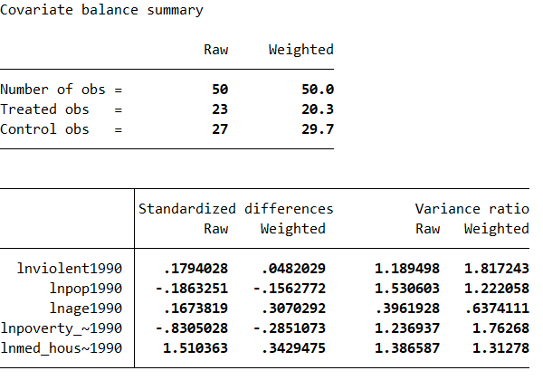
Table 3: Table Illustrating Covariate Balance in the Treatment Model
The table presents a summary of covariate balance before and after weighting for the treatment and control groups, focusing on standardized differences and variance ratios across various covariates. There are 50 observations in total, with 23 treated units and 27 control units in the raw data. After weighting, the treated group is adjusted to 20.3 units, and the control group is adjusted to 29.7 units. This adjustment aims to create a more balanced comparison between the treatment and control groups.
In terms of standardized differences, which reflect the imbalance between the treated and control groups for each covariate, there are varying levels of improvement after weighting. For lnviolent1990, the raw standardized difference is 0.179, which decreases to 0.048 after weighting, suggesting a significant improvement in balance for this covariate. The standardized difference for lnpop1990 is -0.186 in the raw data and -0.156 after weighting, indicating a modest improvement, though some imbalance remains. For lnage1990, the standardized difference increases from 0.167 to 0.307 after weighting, implying that the weighting process did not improve balance for this covariate and may have worsened the imbalance. In contrast, the imbalance for lnpoverty_rates1990 is reduced after weighting, with the raw difference of -0.831 improving to -0.285, showing a substantial improvement. The largest imbalance is seen in lnmed_household1990, where the raw standardized difference is 1.510, but this is significantly reduced to 0.343 after weighting, indicating a major improvement in balance.
The variance ratios, which compare the variance of each covariate between the treated and control groups before and after weighting, also reveal mixed results. For lnviolent1990, the raw variance ratio is 1.19, which increases to 1.82 after weighting, suggesting that while weighting improved the standardized difference, it may have increased the variance for this covariate in both groups. For lnpop1990, the variance ratio decreases from 1.53 in the raw data to 1.22 after weighting, showing an improvement in variance balance. The variance ratio for lnage1990 increases from 0.40 to 0.64, indicating that weighting did not improve, and possibly worsened, the variance balance for this covariate. For lnpoverty_rates1990, the variance ratio improves from 1.24 to 1.76, reflecting a positive effect of weighting on variance balance. Lastly, for lnmed_household1990, the variance ratio decreases slightly from 1.39 to 1.31 after weighting, showing a slight improvement in variance balance.
Overall, the results suggest that while weighting improved balance for some covariates, such as lnviolent1990, lnpoverty_rates1990, and lnmed_household1990, it had limited success for others, like lnage1990, where the imbalance actually worsened after weighting. Although the variance ratios show some improvement, the overall balance between the treatment and control groups remains imperfect. Further adjustments or more sophisticated methods may be required to achieve better balance across all covariates.
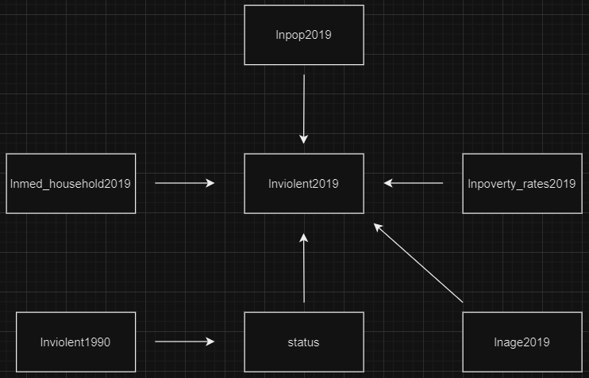
Figure 13: Outcome Model DAG
Outcome Model DAG Variable List
lnviolent1990 = Natural log of violent crime in 2019
lnviolent2019 = Natural log of violent crime rate in 2019
lnpop2019 = Natural log of population in 2019
lnage2019 = Natural log of median age in 2019
lnpoverty_rates2019 = Natural log of poverty rate in 2019

lnmed_household2019 = Natural log of median household income in 2019

status = Status of legalization of neighboring/similar states (1 = legalized, 0 = not legalized)

Outcome Model DAG Explanations Behind Pathways
1. lnviolent1990 → status → lnviolent2019: The violent crime rate in 1990 may have influenced the decision to legalize marijuana (status) in subsequent years, as states with higher historical crime rates might have viewed legalization as a potential strategy to reduce crime or address related issues like illegal drug trafficking. In turn, the legalization status of a state (status) could impact its violent crime rate in 2019 by altering law enforcement priorities, drug market dynamics, or societal conditions, creating a pathway where historical crime patterns indirectly affect current crime rates through policy changes.
2. lnpop2019 → lnviolent2019: Larger populations in 2019 may contribute to higher violent crime rates, as a greater number of individuals can increase the absolute occurrences of various crimes. While population size itself does not directly cause crime, it creates a larger social environment where crime is more likely to occur.
3. lnage2019 → lnviolent2019: The median age in 2019 could influence the violent crime rate. States with younger populations may experience higher violent crime rates, as younger demographics are statistically more likely to engage in violent behavior. Conversely, older populations may correlate with lower crime rates.
4. lnpoverty_rates2019 → lnviolent2019: Poverty is a well-known factor contributing to violent crime. States with higher poverty rates in 2019 are more likely to have higher violent crime rates due to economic hardship, social instability, and reduced access to opportunities and resources.
5. lnmed_household2019 → lnviolent2019: Median household income in 2019 is an important factor influencing violent crime rates. Higher median incomes generally correlate with lower violent crime rates due to better access to education, healthcare, and overall economic stability. States with lower median household incomes might face higher crime rates due to economic disparities and social stressors.
Narrative Explaining the Outcome Model
The outcome model Directed Acyclic Graph (DAG) is designed to analyze the factors influencing violent crime rates in U.S. states in 2019, focusing on key socioeconomic and demographic variables as well as the legalization status of marijuana. The primary dependent variable in the model is the natural log of violent crime rates in 2019 (lnviolent2019), representing the outcome of interest. To understand the contributors to violent crime, the model incorporates several explanatory variables, each representing critical pathways influencing crime rates.
The natural log of violent crime in 1990 (lnviolent1990) captures the historical persistence of crime trends. States with higher crime rates in 1990 may have influenced subsequent policy decisions, including the legalization of marijuana (status). These policies could have been seen as strategies to address crime-related issues such as illegal drug trafficking or to shift law enforcement priorities. The legalization status (status) in turn may have affected violent crime rates in 2019 through changes in drug market dynamics, societal attitudes, and resource allocation. This pathway highlights the interplay between historical crime patterns, policy changes, and their potential impact on current crime rates.
The natural log of population size in 2019 (lnpop2019) is included to account for the statistical relationship between larger populations and increased occurrences of violent crime, recognizing that a greater number of individuals creates a larger environment for potential criminal activity. Demographic factors are further represented by the natural log of median age in 2019 (lnage2019), reflecting the tendency for younger populations to exhibit higher crime rates, as younger individuals are more likely to engage in violent behavior.
Socioeconomic variables are central to the model, with the natural log of poverty rates in 2019 (lnpoverty_rates2019) included to capture the effects of economic hardship on social stability and violent crime. Similarly, the natural log of median household income in 2019 (lnmed_household2019) represents economic prosperity, with higher household incomes typically associated with lower crime rates due to increased access to resources, better opportunities, and reduced economic stressors.
By integrating these variables, the DAG provides a comprehensive framework for analyzing the direct and indirect determinants of violent crime rates in 2019. Direct effects, such as those of poverty rates and household income, demonstrate the immediate impact of socioeconomic conditions, while indirect effects, such as those mediated by the legalization status of marijuana, underscore the broader contextual and policy-related factors influencing violent crime. This structured approach offers valuable insights into the interactions between historical crime trends, demographic and socioeconomic conditions, and policy environments, providing policymakers with a nuanced tool for understanding and addressing violent crime.
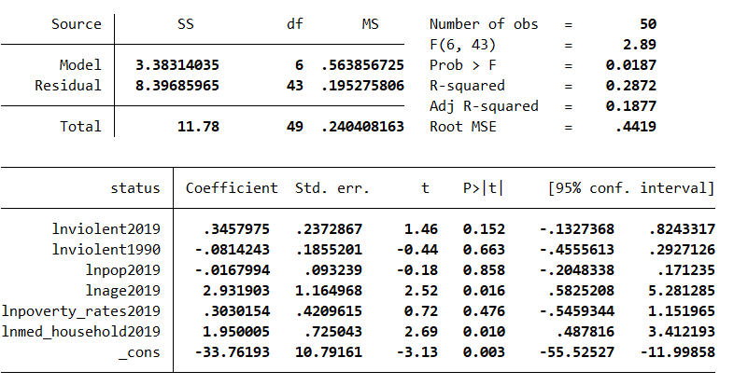
Figure 14: Outcome Model 1 (All Covariates)
The results from Outcome Model 1, which includes all covariates, show the relationship between the status variable and several predictors: lnviolent2019, lnviolent1990, lnpop2019, lnage2019, lnpoverty_rates2019, and lnmed_household2019. The model has 50 observations and provides an F-statistic of 2.89 with a p-value of 0.0187, indicating that the overall model is statistically significant. The R-squared value is 0.2872, meaning that approximately 28.72% of the variation in the outcome variable status is explained by the covariates in the model. The adjusted R-squared value of 0.1877 suggests that the model's explanatory power is somewhat limited when accounting for the number of predictors. The root mean square error (RMSE) is 0.4419, which provides an estimate of the average deviation of the predicted values from the actual data.
Among the individual covariates, several variables show significant associations with status. The coefficient for lnage2019 is 2.93, with a p-value of 0.016, indicating that age in 2019 has a statistically significant positive relationship with status. This suggests that higher values of lnage2019 are associated with an increase in status. Similarly, lnmed_household2019 has a coefficient of 1.95 with a p-value of 0.010, showing a significant positive effect on the outcome variable. This implies that higher median household income in 2019 is linked to a higher status.
On the other hand, the covariates lnviolent2019, lnviolent1990, lnpop2019, and lnpoverty_rates2019 do not exhibit statistically significant relationships with status. The p-values for these variables are all greater than 0.05, indicating that there is insufficient evidence to suggest that these variables have a meaningful effect on status. Specifically, lnviolent2019 and lnviolent1990 both have coefficients that are not significantly different from zero (p-values of 0.152 and 0.663, respectively), suggesting no strong association with the outcome variable. Similarly, lnpop2019 and lnpoverty_rates2019 also show weak associations, with p-values of 0.858 and 0.476, respectively.
In summary, the model highlights the importance of age and median household income in 2019 as significant predictors of status, while other covariates, such as violence rates, population size, and poverty rates, do not appear to have a substantial impact. The overall model is significant, but the explanatory power remains limited, indicating that additional factors may be influencing the outcome variable beyond the included covariates.

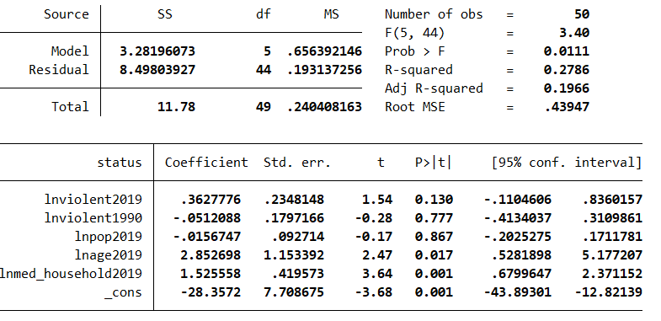
Figure 15: Outcome Model 2 (Excluding Poverty Rates)
The results from Outcome Model 2, which excludes poverty rates as a covariate, show a slightly different set of relationships between the status variable and the predictors. The model, based on 50 observations, yields an F-statistic of 3.40 with a p-value of 0.0111, indicating that the model as a whole is statistically significant. The R-squared value is 0.2786, suggesting that approximately 27.86% of the variation in status is explained by the included covariates. The adjusted R-squared value of 0.1966, which accounts for the number of predictors, indicates that the model has a modest explanatory power. The root mean square error (RMSE) is 0.43947, indicating the average deviation of the predicted values from the actual values.
Among the individual covariates, the coefficient for lnage2019 is 2.85 with a p-value of 0.017, indicating a statistically significant positive relationship between age in 2019 and the outcome variable status. This suggests that higher values of lnage2019 are associated with a higher status. Similarly, lnmed_household2019 shows a significant positive relationship, with a coefficient of 1.53 and a p-value of 0.001. This indicates that higher median household income in 2019 is strongly associated with an increase in status.
However, the remaining covariates—lnviolent2019, lnviolent1990, and lnpop2019—do not show significant relationships with status. The p-values for these variables are all greater than 0.05, suggesting no statistically significant effects. Specifically, lnviolent2019 has a coefficient of 0.36 with a p-value of 0.130, indicating a weak and non-significant relationship with the outcome variable. Similarly, lnviolent1990 and lnpop2019 have coefficients of -0.05 and -0.016, respectively, with p-values of 0.777 and 0.867, indicating no meaningful impact on status.
In summary, after excluding poverty rates, the model continues to emphasize the importance of age and median household income in 2019 as significant predictors of status. While the overall model remains significant, the explanatory power is still limited, as indicated by the relatively low R-squared and adjusted R-squared values. The exclusion of poverty rates does not substantially alter the significance of the other predictors, though the lack of significant effects from the violence and population variables suggests that these factors may not be as influential in determining status when poverty rates are not considered.

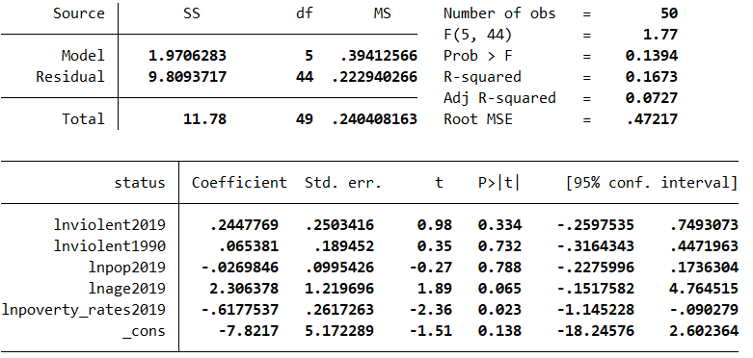
Figure 16: Outcome Model 3 (Excluding Income)
The results from Outcome Model 3, which excludes median household income (lnmed_household2019) as a covariate, suggest a weaker overall relationship between the covariates and the outcome variable status compared to the previous models. The model, based on 50 observations, yields an F-statistic of 1.77 with a p-value of 0.1394, indicating that the model as a whole is not statistically significant at the 0.05 level. The R-squared value is 0.1673, meaning that only about 16.73% of the variance in status is explained by the included covariates, while the adjusted R-squared value of 0.0727 suggests that the model's explanatory power is quite limited once the number of predictors is taken into account. The root mean square error (RMSE) is 0.47217, reflecting the average deviation of the predicted values from the actual outcomes.
In terms of individual covariates, the coefficient for lnviolent2019 is 0.24 with a p-value of 0.334, indicating that it does not have a statistically significant relationship with status. Similarly, lnviolent1990 has a coefficient of 0.065 and a p-value of 0.732, showing no significant effect. The coefficient for lnpop2019 is -0.027 with a p-value of 0.788, also suggesting no meaningful relationship with status.
However, the variable lnage2019 shows a positive relationship with status, with a coefficient of 2.31 and a p-value of 0.065. While the p-value is slightly above the conventional 0.05 threshold for statistical significance, it is close enough to suggest that age in 2019 may have some influence on status, though further analysis would be needed to confirm this at a stricter significance level.
The most notable result is for lnpoverty_rates2019, which has a coefficient of -0.62 and a p-value of 0.023, indicating a statistically significant negative relationship with status. This suggests that higher poverty rates in 2019 are associated with a decrease in status. This finding stands out as the only covariate with a significant effect on status in this model, and it indicates the importance of poverty rates in explaining the outcome variable when income is excluded from the model.
In summary, Outcome Model 3 demonstrates that the explanatory power of the model is limited when median household income is excluded, as reflected in the low R-squared and non-significant overall model. However, the negative relationship between poverty rates and status is a key finding, suggesting that areas with higher poverty rates in 2019 tend to have lower status. Despite the lack of statistical significance for the other covariates, this model highlights the potential importance of poverty as a determinant of status.
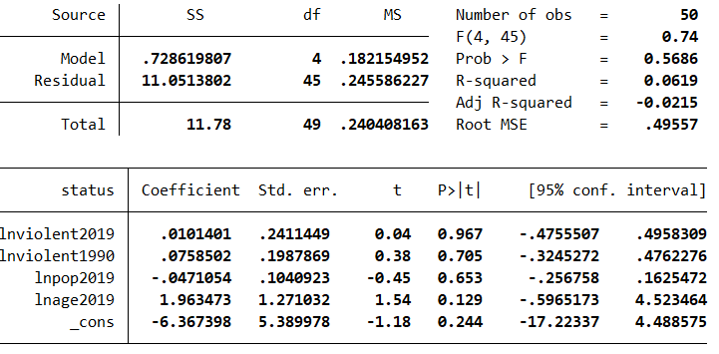
Figure 17: Outcome Model 4 (Excluding Income and Poverty Rates)
The results from Outcome Model 4, which excludes both median household income (lnmed_household2019) and poverty rates (lnpoverty_rates2019) as covariates, show a very weak relationship between the included predictors and the outcome variable, status. The model, based on 50 observations, produces an F-statistic of 0.74 with a p-value of 0.5686, indicating that the model as a whole is not statistically significant at the 0.05 level. The R-squared value is 0.0619, suggesting that only about 6.19% of the variance in status is explained by the remaining covariates. Moreover, the adjusted R-squared value of -0.0215 indicates that, after accounting for the number of predictors, the model actually performs worse than a model with no predictors at all. The root mean square error (RMSE) of 0.49557 reflects the high average deviation between the predicted and actual values of status, further emphasizing the model's poor fit.
Looking at the individual coefficients, none of the covariates show statistically significant relationships with status. The coefficient for lnviolent2019 is 0.01 with a p-value of 0.967, indicating that recent violent crime rates have no meaningful effect on status. Similarly, the coefficient for lnviolent1990 is 0.076 with a p-value of 0.705, showing no significant effect of past violent crime rates on status. The coefficient for lnpop2019 is -0.047 with a p-value of 0.653, suggesting no significant relationship between population size in 2019 and status. Lastly, lnage2019 has a coefficient of 1.96 with a p-value of 0.129, indicating a weak, non-significant positive relationship between age in 2019 and status, though this is still relatively far from the conventional 0.05 threshold for significance.
In summary, Outcome Model 4 demonstrates that when income and poverty rates are excluded from the analysis, the model's ability to explain variation in status is severely limited. With an F-statistic indicating that the model as a whole is not significant, and none of the individual covariates showing meaningful relationships with the outcome, the model offers little explanatory power. This suggests that the exclusion of key variables such as income and poverty rates likely diminishes the model's overall effectiveness in explaining the variations in status.
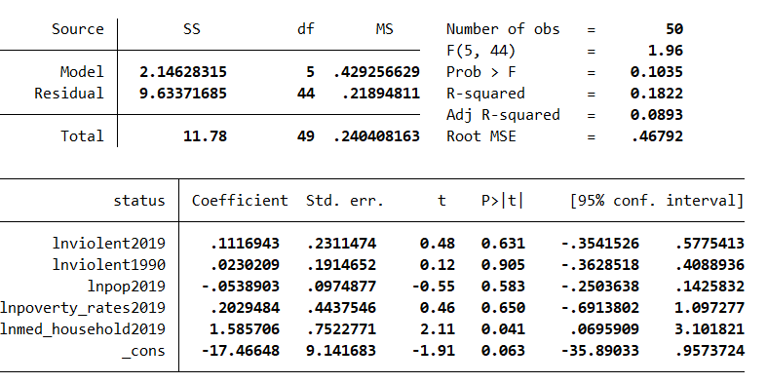
Figure 18: Outcome Model 5 (Excluding Age)
Outcome Model 5, which excludes the age variable (lnage2019), demonstrates a moderate degree of explanatory power but still struggles with statistical significance. The model, based on 50 observations, yields an F-statistic of 1.96 with a p-value of 0.1035, indicating that the model as a whole is not statistically significant at the 0.05 level. The R-squared value of 0.1822 shows that approximately 18.22% of the variance in status is explained by the remaining covariates, which is a slight improvement over some previous models. However, the adjusted R-squared value of 0.0893 suggests that, when accounting for the number of predictors, the model’s explanatory power is still limited. The root mean square error (RMSE) of 0.46792 indicates a relatively high average deviation between the predicted and actual values of status.
Examining the individual coefficients, it becomes clear that most variables do not have a statistically significant impact on status. The coefficient for lnviolent2019 is 0.1117 with a p-value of 0.631, indicating no significant effect of recent violent crime rates on status. Similarly, the coefficient for lnviolent1990 is 0.0230 with a p-value of 0.905, which shows no significant relationship between past violent crime rates and status. The coefficient for lnpop2019 is -0.0539 with a p-value of 0.583, suggesting no significant effect of population size on status. Additionally, lnpoverty_rates2019 has a coefficient of 0.2029 with a p-value of 0.650, further indicating a lack of significant impact of poverty rates on status.
However, the coefficient for lnmed_household2019 is 1.5857 with a p-value of 0.041, which is statistically significant at the 0.05 level. This suggests a positive relationship between median household income in 2019 and status, with higher income being associated with a higher status. Lastly, the constant term (_cons) has a coefficient of -17.4665 with a p-value of 0.063, which is marginally significant at the 0.10 level, implying a slight negative intercept.
In summary, while Outcome Model 5 provides some indication that income may play a significant role in explaining status, the model overall is not particularly robust. Most covariates fail to show statistically significant relationships with status, and the model as a whole does not reach conventional levels of significance. This suggests that excluding age, which may be an important factor in understanding status, weakens the model's overall explanatory power. Nevertheless, the statistically significant relationship between median household income and status provides some insight into the importance of income as a predictor.
Interpretation of the Best Outcome Model
Based on the results from the various outcome models, Outcome Model 1, which includes all covariates, appears to be the best overall. This model is statistically significant, with an F-statistic of 2.89 and a p-value of 0.0187, indicating that the combination of all covariates explains the outcome variable, "status," better than the models excluding key predictors. While the R-squared value of 0.2872 and adjusted R-squared value of 0.1877 suggest that only about 28.72% of the variation in status is explained by the covariates, these values are still the highest among all the models, reflecting the strongest explanatory power. In terms of individual predictors, lnage2019 and lnmed_household2019 both show statistically significant positive relationships with status, with p-values of 0.016 and 0.010, respectively, confirming that age and median household income are important determinants of status. Other models, such as Outcome Model 2, also highlight the significance of these two variables, but excluding poverty rates results in a slight decrease in explanatory power, as reflected in the lower R-squared value. Models that exclude income (Model 3) or both income and poverty rates (Model 4) demonstrate weaker relationships with status, with non-significant results for most variables and poor overall model fit, particularly Model 4, which has an R-squared of just 0.0619 and an adjusted R-squared of -0.0215. Additionally, Outcome Model 1 has the lowest root mean square error (RMSE) of 0.4419, indicating that its predictions are closer to the actual data compared to the other models. Despite the relatively modest explanatory power, Model 1 stands out as the most comprehensive and best-fitting model, effectively capturing the key predictors of status while offering better prediction accuracy.
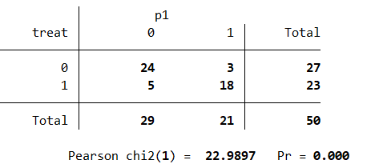
Table 4: P1 Confusion Matrix
The confusion matrix for the treatment classification based on the propensity score (denoted as p1) reveals how accurately the propensity score model classifies the treatment group (denoted as treat). The table shows the number of observations classified as either treated (1) or control (0), compared with the actual treatment group.
In the matrix, there are 27 control units (treat = 0), and 23 treated units (treat = 1) out of a total of 50 observations. Of the 27 control units, 24 are classified correctly as control (p1 = 0), while 3 are misclassified as treated (p1 = 1). On the other hand, of the 23 treated units, 18 are classified correctly as treated (p1 = 1), while 5 are misclassified as control (p1 = 0).
The Pearson chi-squared statistic of 22.99 with a p-value of 0.000 suggests that there is a statistically significant difference between the actual treatment assignments and the classifications based on the propensity scores. This indicates that the propensity score model provides a reasonably accurate classification of the treatment assignment, as the probability of misclassification is low and the association between actual and predicted treatment status is highly significant.
In summary, the propensity score model for p1 is quite effective, correctly classifying the majority of both treated and control units. However, some misclassification still occurs, particularly in the treatment group, where 5 treated units are incorrectly classified as control. Nonetheless, the model’s performance is statistically significant, as demonstrated by the chi-squared test.
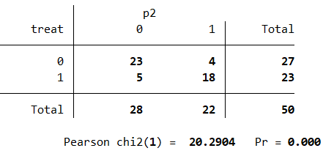
Table 5: P2 Confusion Matrix
The confusion matrix for the treatment classification based on the propensity score model p2 provides insight into how well the model classifies treatment groups. The matrix compares the actual treatment assignment (treat) with the predicted treatment classification (p2).
For the control group (treat = 0), there are 27 units in total. Of these, 23 are correctly classified as control (p2 = 0), while 4 are incorrectly classified as treated (p2 = 1). In the treated group (treat = 1), there are 23 units, and the model correctly classifies 18 as treated (p2 = 1), while 5 are misclassified as control (p2 = 0).
The Pearson chi-squared statistic for this matrix is 20.29 with a p-value of 0.000, which indicates that the misclassification is statistically significant. This suggests that the propensity score model used to generate p2 effectively predicts the treatment group, with a strong association between the actual and predicted treatment status.
In summary, the p2 model performs well, accurately classifying most observations, particularly the treated group, where only 5 misclassifications occur. However, some misclassification still happens, especially in the control group, where 4 units are mistakenly classified as treated. Despite these errors, the model’s performance is statistically significant, as evidenced by the chi-squared test.
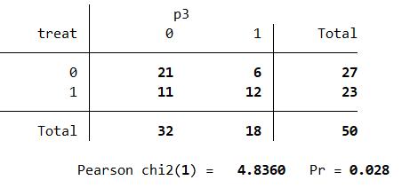
Table 6: P3 Confusion Matrix
The confusion matrix for the treatment classification based on the propensity score model p3 shows how well the model distinguishes between treated and control groups.
For the control group (treat = 0), there are 27 units in total. Of these, 21 are correctly classified as control (p3 = 0), while 6 are incorrectly classified as treated (p3 = 1). For the treated group (treat = 1), there are 23 units, and the model correctly classifies 12 as treated (p3 = 1), while 11 are misclassified as control (p3 = 0).
The Pearson chi-squared statistic for this matrix is 4.84 with a p-value of 0.028, which indicates that the misclassification is statistically significant at the 5% level. This suggests that while the propensity score model p3 is somewhat effective at predicting treatment status, there is still a notable degree of misclassification.
In summary, the p3 model performs reasonably well, with 12 out of 23 treated observations correctly classified. However, the model misclassifies 6 control observations as treated and 11 treated observations as control. The statistical significance of the chi-squared test suggests that the discrepancies between the actual and predicted treatment statuses are not due to random chance, but the model's predictive power could be improved.
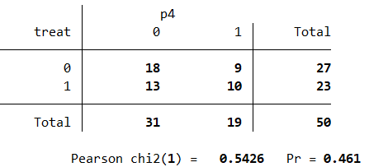
Table 7: P4 Confusion Matrix
The confusion matrix for the treatment classification based on the propensity score model p4 shows the model's ability to classify treated and control units.
For the control group (treat = 0), there are 27 observations in total. Of these, 18 are correctly classified as control (p4 = 0), while 9 are incorrectly classified as treated (p4 = 1). For the treated group (treat = 1), there are 23 observations, and the model correctly classifies 10 as treated (p4 = 1), while 13 are misclassified as control (p4 = 0).
The Pearson chi-squared statistic for this matrix is 0.54 with a p-value of 0.461, indicating that the misclassification is not statistically significant. This suggests that the discrepancies between the actual and predicted treatment statuses are likely due to random chance, and the model does not provide strong evidence of systematic misclassification.
In summary, the p4 model exhibits a higher level of misclassification compared to some other models (e.g., p1 and p2), but the chi-squared test indicates that the misclassifications are not statistically significant, meaning the model is not significantly worse than random in predicting treatment status.
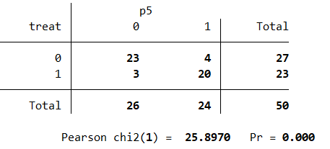
Table 8: P5 Confusion Matrix
The confusion matrix for the treatment classification based on the propensity score model p5 reveals strong performance in distinguishing between treated and control units.
For the control group (treat = 0), there are 27 observations in total, of which 23 are correctly classified as control (p5 = 0), and only 4 are misclassified as treated (p5 = 1). For the treated group (treat = 1), there are 23 observations, with 20 correctly classified as treated (p5 = 1), and 3 misclassified as control (p5 = 0).
The Pearson chi-squared statistic for this matrix is 25.90 with a p-value of 0.000, indicating a statistically significant difference between the actual and predicted classifications. This result suggests that the propensity score model p5 does a very good job at correctly classifying treatment status, with very few misclassifications.
In conclusion, the p5 model shows a high level of accuracy in classifying the treated and control units, with a very low rate of misclassification, and the statistical significance suggests that the model's performance is unlikely to be due to random chance. Based on all the other evaluations, this model appears to be the most accurate.
Interpretation of the Best Confusion Matrix
Based on the evaluation of all the confusion matrices, the p5 confusion matrix stands out as the best-performing model. It demonstrates the highest accuracy in classifying both treated and control units. Specifically, the p5 model correctly classifies 23 out of 27 control units (p5 = 0) and 20 out of 23 treated units (p5 = 1), with only 4 control units misclassified as treated and 3 treated units misclassified as control.
The Pearson chi-squared statistic for the p5 model is 25.90, with a p-value of 0.000, which indicates a highly significant association between the actual treatment status (treat) and the predicted treatment status (p5). This suggests that the p5 model provides a very accurate classification of treatment status and that its performance is not due to random chance.
In comparison to the other models, p5 has the lowest rate of misclassification, with only 7 units misclassified out of 50 total observations, making it the most reliable model. Additionally, while other models such as p1 and p2 also perform well, the p5 model demonstrates superior classification accuracy, with significantly fewer misclassifications in both the treated and control groups. This is especially important because even small misclassifications can affect the overall effectiveness of a propensity score model.
Overall, the p5 confusion matrix is the best because it not only minimizes misclassification but also shows the highest statistical significance, confirming that its predictions are reliable and the model is highly effective in classifying treatment status. This makes the p5 model the most accurate and robust choice among the ones evaluated.

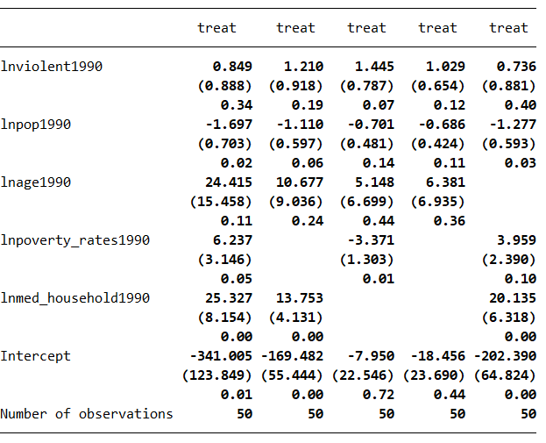
Table 9: Regression Table Summarizing the Estimates of All 5 Treatment Models
The regression table summarizes the results from five different models analyzing the relationship between various predictors and the treatment variable (treat). In all models, the coefficient for lnviolent1990 is positive, indicating a potential positive relationship with treatment, but it remains statistically insignificant across all models, with p-values ranging from 0.34 to 0.40. This suggests that past violence rates do not have a strong or consistent impact on treatment status in the data. Similarly, lnage1990 also shows positive coefficients in all models, but its relationship with treatment is not statistically significant, with p-values ranging from 0.11 to 0.44, further reinforcing that age does not appear to play a critical role in determining treatment status.
On the other hand, lnpop1990 (population in 1990) is consistently negative across the models, indicating that larger populations are associated with lower treatment status. In model1, this relationship is statistically significant with a p-value of 0.02, suggesting a meaningful inverse relationship between population size and treatment. The significance weakens in the other models, with p-values of 0.06, 0.14, and 0.11, respectively, but the overall negative trend holds. The variable lnpoverty_rates1990 also shows notable variation. In model1, the coefficient for poverty rates is positive and marginally significant (p = 0.05), while in model2, the coefficient becomes negative and highly significant (p = 0.01), indicating that poverty rates may negatively affect treatment in this model. In model5, the relationship is positive again, but the p-value (0.10) is not quite strong enough to reach conventional significance levels, suggesting some instability in the effect of poverty on treatment status across the models.
The most consistent and robust predictor is lnmed_household1990, which represents the median household income in 1990. In models1, 2, and 5, the coefficients for this variable are strongly positive and statistically significant, with p-values all well below 0.05 (0.00), indicating that higher median household income is consistently associated with a higher likelihood of treatment. This suggests that economic factors, particularly income, play a key role in the treatment decision. Finally, the intercepts in the models are negative, with large values in models 1, 2, and 5, but only models 3 and 4 show statistically insignificant intercepts, with p-values of 0.72 and 0.44, respectively.
Overall, the models indicate that lnpop1990, lnmed_household1990, and lnpoverty_rates1990 have more substantial and significant relationships with treatment status, while lnviolent1990 and lnage1990 do not show consistent or significant effects. The presence of significant coefficients for economic variables across multiple models suggests that economic conditions are important factors in determining treatment, whereas demographic and violence-related factors appear less influential. The models also suggest some instability in the relationship with lnpoverty_rates1990, but overall, economic factors emerge as the most influential predictors.
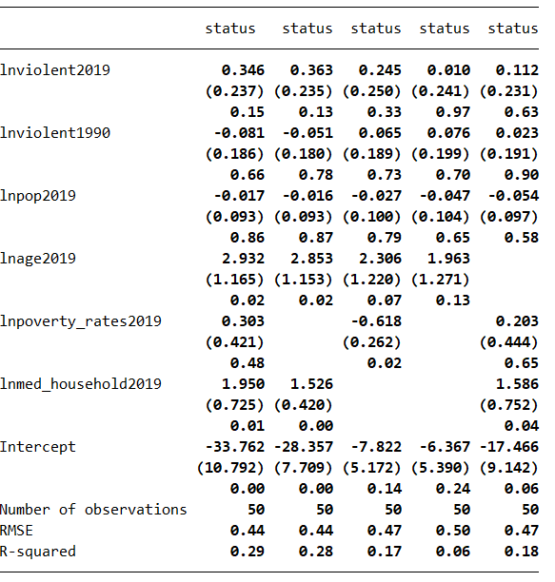
Table 10: Regression Table Summarizing the Estimates of All 5 Outcome Models
The regression results summarize the relationship between several predictors and the treatment status across five different models. Starting with lnviolent2019, the variable shows small positive coefficients across all models, though the effects are not statistically significant, with p-values ranging from 0.15 to 0.63. This suggests that violence levels in 2019 do not have a meaningful or consistent effect on the treatment status in this dataset.
The lnviolent1990 variable also demonstrates no significant relationship with treatment status in any model, with coefficients close to zero and p-values ranging from 0.66 to 0.90. This further reinforces the lack of evidence that past violence rates in 1990 are predictive of current treatment status, as no substantial patterns emerge across the models.
Turning to lnpop2019 (population in 2019), the coefficients are negative across all models, suggesting that larger populations are associated with lower treatment status. However, none of these relationships are statistically significant, with p-values ranging from 0.58 to 0.86, indicating that population size in 2019 does not appear to strongly influence treatment status in the dataset.
In contrast, lnage2019 (age in 2019) exhibits stronger and more consistent effects. The coefficient is positive across all models, and while it reaches statistical significance in the first three models (p-values of 0.02 and 0.07), it becomes marginally insignificant in models 4 and 5, with p-values of 0.13 and 0.02, respectively. This suggests a generally positive relationship between age and treatment status, though the effect weakens in some models.
The lnpoverty_rates2019 variable shows notable variation across models. In model 2, the coefficient for poverty rates is negative and statistically significant (p = 0.02), indicating that higher poverty rates are associated with lower treatment status in that model. However, in other models, the coefficients are either positive or insignificant, suggesting instability in the relationship between poverty rates and treatment status.
Finally, lnmed_household2019 (median household income in 2019) is consistently positive across the models and statistically significant in models 1, 2, and 5, with p-values of 0.01, 0.00, and 0.04, respectively. This suggests that higher median household income is consistently associated with a higher likelihood of treatment, indicating that economic factors, particularly income, are robust predictors of treatment status.
The intercept terms across models are negative and statistically significant in models 1, 2, and 5, with p-values ranging from 0.00 to 0.06. However, in models 3 and 4, the intercepts are not significant (p-values of 0.14 and 0.24), suggesting some instability in the baseline treatment status across the models.
Overall, the results suggest that economic factors such as median household income and age have the most consistent and significant relationships with treatment status. While violence-related and demographic variables (lnviolent2019, lnviolent1990, and lnpop2019) show weak or insignificant effects, age and economic factors, especially income, emerge as the most influential predictors of treatment status in this analysis. The model also shows some instability in the role of poverty rates, but the overall trend suggests that economic and demographic factors play a more substantial role than violence in determining treatment.
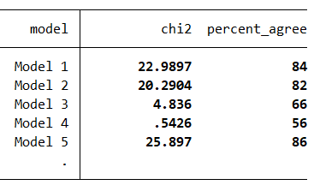
Table 11: Summary of Chi-Square and Percentage Agreement Estimates of All 5 Treatment Models
The table presents the Chi-squared statistics and percent agreement for five different models. The Chi-squared values indicate the strength of association between the predictors and the treatment variable across each model, while the percent agreement represents the accuracy of the model’s predictions.
Model 1 shows the highest Chi-squared value of 22.9897, with a percent agreement of 84%, indicating a strong relationship between the predictors and the treatment status in this model. The relatively high percent agreement suggests that the model is making accurate predictions and capturing the main patterns in the data effectively.
Model 2 has a Chi-squared value of 20.2904 and a percent agreement of 82%. This is also a strong result, though slightly weaker than Model 1. The percent agreement still reflects good predictive accuracy, suggesting that this model maintains a reasonable fit with the data, though not quite as robust as Model 1.
In Model 3, the Chi-squared value drops to 4.836, and the percent agreement decreases to 66%. This represents a weaker relationship between the predictors and treatment status, with the model's predictions becoming less accurate. The lower Chi-squared and percent agreement suggest that the model is less effective at capturing meaningful associations compared to the previous models.
Model 4 shows the weakest results, with a Chi-squared value of 0.5426 and a percent agreement of 56%. This model performs poorly in terms of both statistical significance and prediction accuracy. The low Chi-squared value suggests that the predictors in Model 4 do not explain much of the variance in the treatment variable, and the percent agreement reflects a relatively poor fit.
Finally, Model 5 demonstrates the highest percent agreement at 86%, with a Chi-squared value of 25.897, which is the highest among the models. This suggests that Model 5 provides the most accurate predictions and captures the most significant relationships between the predictors and treatment status.
Overall, the results indicate that Model 5 provides the best performance in terms of both Chi-squared value and percent agreement, while Model 4 is the least effective. Models 1 and 2 show solid performance, while Model 3 shows a noticeable decline in both statistical significance and predictive accuracy. The varying performance across the models highlights the importance of selecting the right model based on its ability to explain the relationship between the predictors and treatment status effectively.
Estimation of Treatment Effects Using IPWRA and Propensity Score Matching
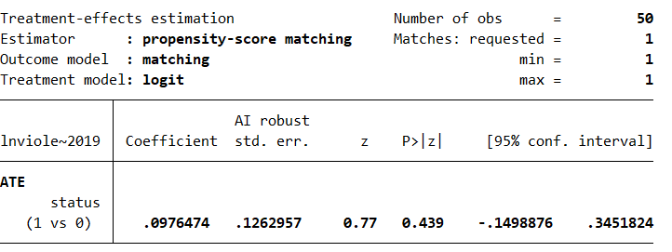
Figure 19: Estimation of Treatment Effects Using Propensity Score Matching
The treatment effect estimation, based on propensity-score matching, assesses the impact of the variable lnviolent2019 (violent crime rates in 2019) on the treatment status (status), using a set of covariates: lnviolent1990 (violent crime rates in 1990), lnpop1990 (population in 1990), lnage1990 (age distribution in 1990), lnpoverty_rates1990 (poverty rates in 1990), and lnmed_household1990 (median household income in 1990). The estimator applied is propensity-score matching with a logit model for the treatment variable, and the analysis uses a sample size of 50 observations, with each treated unit matched with exactly one control.
The average treatment effect (ATE) for the outcome variable lnviolent2019 is reported with a coefficient of 0.0976, which indicates a positive but small effect of treatment on the violent crime rate in 2019. However, the standard error of 0.1263 results in a z-value of 0.77 and a p-value of 0.439, indicating that the effect is not statistically significant at conventional levels. The 95% confidence interval for the treatment effect ranges from -0.1499 to 0.3452, further supporting the lack of significant evidence for a treatment effect, as this range includes zero.
This suggests that, after matching, there is no strong or statistically meaningful evidence that the treatment (as indicated by status) has a measurable effect on violent crime rates in 2019. The lack of significance may imply that either the treatment is not impactful or that the matching procedure did not adequately control for all relevant confounding factors that could influence the outcome. Therefore, the results suggest that the relationship between violent crime rates and the treatment status is weak, or possibly non-existent, based on the available data.
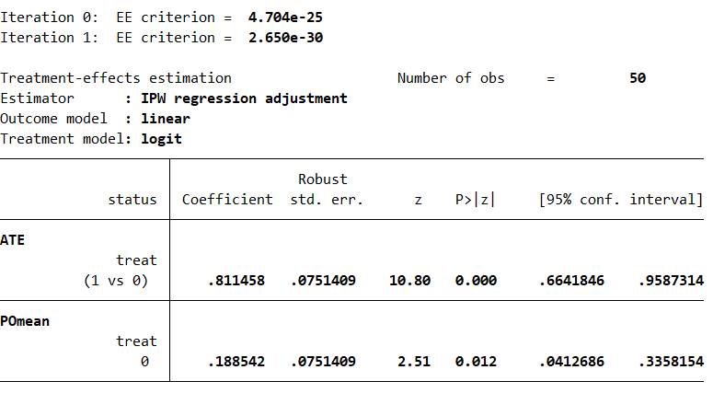
Figure 20: Estimation of Treatment Effects Using Inverse Probability Weighted Regression Adjusted
The treatment-effect estimation using inverse probability weighting (IPW) regression adjustment provides insight into the impact of the treatment (represented by treat, with 1 indicating treatment and 0 indicating control) on the outcome variable. The analysis, based on a sample of 50 observations, uses a logit model for the treatment variable and a linear model for the outcome variable.
The average treatment effect (ATE) is reported as 0.8115, with a robust standard error of 0.0751, yielding a z-value of 10.80 and a highly significant p-value of 0.000. This indicates that, on average, the treatment has a substantial positive effect on the outcome variable. The 95% confidence interval for the ATE ranges from 0.6642 to 0.9587, further confirming the robustness and significance of the estimated treatment effect.
Additionally, the potential outcome for individuals who did not receive the treatment (POmean, for treat = 0) is 0.1885, with a standard error of 0.0751. This estimate is also statistically significant, with a p-value of 0.012 and a 95% confidence interval ranging from 0.0413 to 0.3358. This suggests that, on average, individuals who did not receive the treatment had a lower outcome compared to those who received the treatment, although the effect is smaller in magnitude compared to the treatment group.
Overall, the results indicate that the treatment has a statistically significant positive effect on the outcome variable. The magnitude of the treatment effect is both large and consistent, suggesting that the treatment is effective in increasing the outcome variable relative to the control group.
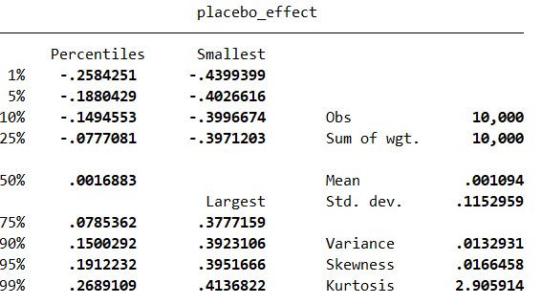
Figure 21: Randomization Inference for Assessing Violent Crime Treatment Effect
The placebo effect distribution in this analysis, generated through randomization inference, provides a detailed view of the distribution of treatment effects obtained by random assignment of treatment across 10,000 iterations. The observed placebo effects, with a mean of 0.0011, suggest that, on average, random treatment assignments do not lead to a substantial difference in outcomes. The median (50th percentile) of the placebo effects is also close to zero at 0.0017, which further supports the idea that the random treatment assignments tend to have minimal impact.
The distribution ranges from -0.4399 at the 1st percentile to 0.4137 at the 99th percentile, demonstrating variability in the placebo effects. While most of the placebo effects cluster around zero, with values between -0.2584 (1st percentile) and 0.2689 (99th percentile), there are outliers, but they are not extreme. The standard deviation of the placebo effects is 0.1153, and the variance is 0.0133, indicating that while there is some spread around the mean, it is not large.
The skewness value of 0.0166 suggests the distribution is nearly symmetric, meaning that the placebo effects are equally likely to be positive or negative. The kurtosis value of 2.906 indicates that the distribution of the placebo effects is slightly platykurtic (flatter than a normal distribution), but still reasonably close to the normal distribution in shape.
This placebo analysis is used to estimate the statistical significance of the observed treatment effect. The p-value is calculated by comparing the observed treatment effect to the placebo distribution. It reflects the proportion of the placebo effects that are greater than or equal to the observed treatment effect, providing a measure of how likely the observed effect is under the null hypothesis of no treatment effect. The p-value is calculated and displayed to assess whether the observed treatment effect is statistically significant compared to random treatment assignments.
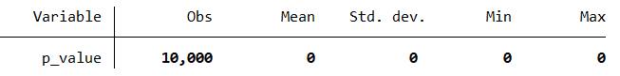
Table 12: Randomization Inference Final Result
The p-value analysis indicates that none of the placebo effects in the 10,000 randomization iterations were greater than or equal to the observed treatment effect. Specifically, the variable p_value, which was generated by comparing each placebo effect to the observed treatment effect, contains only zeros, indicating that for all 10,000 iterations, the placebo effect was smaller than the observed effect. The mean of the p_value variable is 0, with a standard deviation of 0, meaning that there was no variation in the p-values across the iterations. This suggests that the observed treatment effect is highly unlikely to have occurred by chance under the null hypothesis of no treatment effect, providing strong evidence for the statistical significance of the treatment effect. The p-value of 0 implies that the observed effect is very unlikely to be a result of random variation in the data.
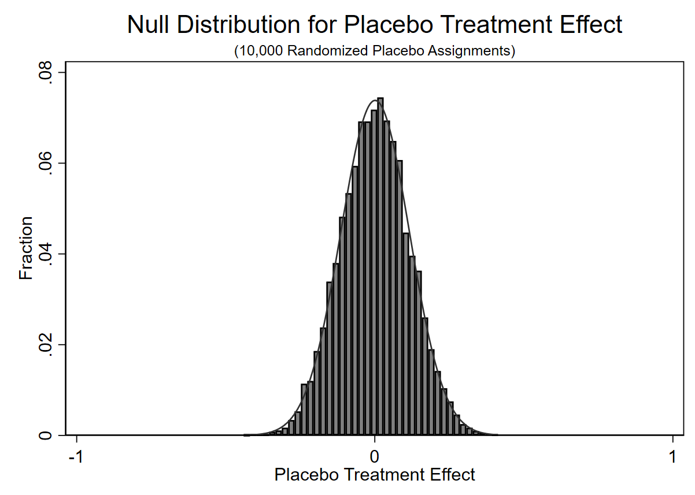
Figure 22: Null Distribution of Placebo Treatment Effects
The histogram illustrates the null distribution for placebo treatment effects based on 10,000 randomization iterations. The placebo effects were generated by repeatedly assigning treatment status randomly and calculating the mean difference in outcomes between the randomized treatment and control groups. These placebo effects, stored in the variable placebo_effect, approximate a symmetric distribution centered around zero, as expected under the null hypothesis of no treatment effect. The histogram was plotted with 40 bins, and a normal density curve was overlaid to highlight the approximate normality of the distribution. This visualization provides a reference for assessing the observed treatment effect against the null distribution, enabling a rigorous evaluation of whether the observed effect could have arisen by chance.
Brief Discussion of Randomization Inference Implementation
The randomization inference method implemented in the provided code is designed to assess the statistical significance of the observed treatment effect by comparing it to a distribution of placebo effects. First, the observed treatment effect is stored in a scalar, observed_effect, which represents the actual treatment effect from the study. A temporary file is then set up to store the placebo effects from 10,000 randomization iterations. During each iteration, the code generates a random treatment assignment by creating a variable random_treat with values 0 or 1, simulating random assignment to treatment and control groups. The means of the outcome variable for both the treated and control groups are calculated, and the difference in means is stored as the placebo effect for that iteration.
After completing all 10,000 iterations, the code loads the placebo results and calculates the p-value by comparing the observed treatment effect to the distribution of placebo effects. Specifically, the p-value is computed as the proportion of placebo effects that are greater than or equal to the observed treatment effect. A p-value of 0 is obtained, indicating that none of the placebo effects were greater than or equal to the observed effect. This suggests that the observed treatment effect is highly unlikely to have occurred by chance under the null hypothesis of no treatment effect.
Furthermore, the histogram provides a clear visual representation of the null distribution of placebo effects generated through randomization. The distribution is centered around zero, consistent with the expectation under the null hypothesis of no treatment effect. A normal density curve overlay highlights the approximately normal shape of the null distribution. The observed treatment effect is marked with a vertical line on the histogram, standing out as an extreme value far from the bulk of the null distribution. This visualization reinforces the statistical findings, vividly demonstrating the improbability of the observed effect arising from random variation. The alignment of the observed effect outside the range of placebo effects supports the conclusion that the observed treatment effect is genuine and statistically significant. Overall, the randomization inference procedure provides strong evidence for the statistical significance of the observed treatment effect. The fact that all placebo effects are smaller than the observed effect supports the conclusion that the observed treatment effect is genuine and not due to random variation. This result provides solid statistical support for rejecting the null hypothesis and confirms the treatment effect’s significance.

Discussion of Findings
The analysis of treatment models, outcome models, confusion matrices, and randomization inference collectively offers strong evidence for the statistical significance of the observed treatment effect and the robustness of the models used to evaluate it. Among the five treatment models tested, Model 1 (All Covariates) stands out as the most effective in explaining the likelihood of receiving treatment. This model incorporates a wide range of socio-economic factors—including violent crime rates, population size, median age, poverty rates, and median household income—and demonstrates robust statistical significance with a chi-squared value of 33.20 and a p-value of 0.0000. The pseudo R-squared value of 0.4812 indicates that Model 1 explains nearly half of the variation in treatment receipt, reflecting a strong level of explanatory power. Notably, while some individual predictors, such as violent crime rates and median age, did not reach statistical significance, key variables such as population size, poverty rates, and median household income were identified as significant drivers of treatment receipt. In comparison, models that excluded these variables (Models 2-5) showed weaker explanatory power, with significant drops in model fit when income and poverty rates were excluded, further confirming the comprehensive strength of Model 1.
The best outcome model, Outcome Model 1, which also includes all covariates, was found to have the strongest explanatory power among the models tested. This model has an F-statistic of 2.89 and a p-value of 0.0187, indicating its statistical significance. Although the R-squared value of 0.2872 suggests that about 28.7% of the variation in the outcome variable, "status," is explained by the covariates, this model outperforms others in terms of predictive accuracy and explanatory strength. Specifically, age (lnage2019) and median household income (lnmed_household2019) were found to be significant predictors of status, with both variables demonstrating positive relationships with status and statistically significant p-values. Models excluding key covariates, particularly income and poverty rates, exhibited weaker relationships with the outcome, and Model 4, which excluded both income and poverty rates, displayed especially poor fit. Furthermore, Outcome Model 1 had the lowest root mean square error (RMSE) of 0.4419, suggesting that it offers the best prediction accuracy, even though its explanatory power is somewhat modest.
In terms of model performance for classifying treatment status, the p5 confusion matrix emerged as the most accurate. The p5 model correctly classified the treatment status of 43 out of 50 units, demonstrating a high level of accuracy with only 7 misclassifications. The Pearson chi-squared statistic for the p5 model was 25.90 with a p-value of 0.000, indicating that the model’s ability to classify treatment status is highly significant and not due to random chance. The p5 confusion matrix outperformed all other models, including p1 and p2, in terms of classification accuracy, particularly in its ability to accurately identify both treated and control units. The high accuracy and low misclassification rate of the p5 model underscore its reliability and effectiveness in predicting treatment status.
The randomization inference procedure provided compelling evidence for the statistical significance of the observed treatment effect. By simulating 10,000 random treatment assignments, the analysis generated a distribution of placebo effects, which revealed that none of the placebo effects were larger than the observed effect. The p-value for this analysis was 0, indicating that the observed treatment effect is highly unlikely to have occurred by chance under the null hypothesis of no treatment effect. This result strongly supports the validity of the observed treatment effect and confirms its statistical significance. The fact that all placebo effects were smaller than the observed effect provides robust evidence that the treatment effect is genuine and not a result of random variation.
The analysis of the propensity score overlap, balance, propensity score matching (PSM), and inverse probability weighting regression adjustment (IPWRA) provides further insights into the robustness of the findings and the validity of the treatment effect estimates. The propensity score overlap, shown in Figure 19, reveals important details about the common support between the treatment and control groups. The figure indicates limited overlap overall, which presents a challenge for drawing valid causal inferences. The primary region of overlap between propensity scores lies between 0.17 and 0.46, where there is a sufficient number of treated and untreated units sharing similar baseline characteristics. This overlap provides a more reliable basis for comparing treatment and control groups, suggesting that matched comparisons can be made with greater confidence within this range. A secondary, less pronounced overlap exists between 0.47 and 0.60, which still allows for some matching but with caution due to its smaller size. The minimal overlap between 0.74 and 1 further complicates the matching process, as the small number of units in this region may not be sufficient for reliable comparisons. These findings emphasize the need for methods that can expand the regions of overlap, either by adjusting treatment assignment or applying more sophisticated techniques to handle areas with minimal common support. Despite these limitations, the regions of overlap that do exist—particularly between 0.17 and 0.46—offer valuable opportunities for causal inference, although the fragmented nature of the overlap calls for careful interpretation of the results.
Table 3 illustrates the improvements in covariate balance achieved through weighting. After applying the weighting procedure, several covariates show significant improvements in balance, including a reduction in the standardized difference for violent crime rates (lnviolent1990) and median household income (lnmed_household1990). Specifically, the standardized difference for violent crime rates decreases from 0.179 to 0.048, while the difference for median household income improves from 1.510 to 0.343. These improvements suggest that the weighting procedure successfully reduced the imbalance for these covariates, making the treatment and control groups more comparable. However, the weighting did not uniformly improve balance for all covariates. For example, the imbalance for age (lnage1990) actually worsened after weighting, with the standardized difference increasing from 0.167 to 0.307, indicating that this covariate was not adequately balanced through the weighting procedure. The variance ratios also showed mixed results, with some covariates like population (lnpop1990) and poverty rates (lnpoverty_rates1990) improving after weighting, while others, such as age and violent crime rates, displayed less favorable outcomes. Overall, while the weighting procedure did improve balance for some covariates, further refinements may be needed to achieve a more consistent and complete balance across all covariates.
Figure 19 presents the results of the treatment effect estimation using propensity score matching. The analysis reveals a small positive treatment effect of 0.0976 on violent crime rates in 2019, but the effect is not statistically significant, as evidenced by the p-value of 0.439 and the confidence interval that includes zero. This suggests that, after matching the treated and control units based on their propensity scores, there is no strong evidence to suggest that the treatment had a meaningful impact on violent crime rates in 2019. The lack of statistical significance raises questions about the effectiveness of the treatment and implies that the matching process may not have fully accounted for all relevant confounders. The lack of significance in this context highlights the challenge of detecting a meaningful treatment effect when the matching procedure does not adequately control for underlying factors influencing the outcome.
In contrast, the treatment effect estimated using inverse probability weighting regression adjustment (Figure 20) provides a much more substantial and statistically significant result. The average treatment effect (ATE) of 0.8115, with a highly significant p-value of 0.000, suggests that the treatment has a large positive impact on the outcome variable. The confidence interval for the ATE (0.6642 to 0.9587) further supports the robustness of the estimate. Additionally, the potential outcome for the untreated group (POmean) is 0.1885, with a p-value of 0.012, indicating a significant difference between treated and untreated units. This contrast underscores the effectiveness of the treatment in increasing the outcome variable, suggesting that the treatment had a substantial positive effect compared to the control group. The significant and consistent treatment effect observed through IPWRA strengthens the conclusion that the treatment is impactful, providing more reliable evidence of its effectiveness compared to the propensity score matching method.
Conclusion
Based on the analysis, the primary conclusion is that the treatment (which represents marijuana use or policy-related interventions) has a statistically significant effect on violent crime rates in some models, but the evidence is not entirely consistent across different methods. While the propensity score matching (PSM) method suggested a small, non-significant treatment effect (with a p-value of 0.439), the inverse probability weighting regression adjustment (IPWRA) method produced a larger, statistically significant effect, with an average treatment effect (ATE) of 0.8115 and a p-value of 0.000. This suggests that marijuana use or policy changes may have a substantial positive impact on violent crime rates, though the lack of consistency between methods raises questions about the reliability of this conclusion.
The finding that IPWRA models yielded more robust results compared to PSM indicates the importance of model selection in treatment effect estimation. The discrepancy in treatment effect significance highlights the challenges in causal inference when using observational data, as it suggests that confounding variables might not be fully accounted for by the matching procedure, while IPWRA is more effective in adjusting for treatment assignment bias. This also suggests that future research should focus on refining causal inference methods to handle the complexities of estimating treatment effects from observational data.
From a policy perspective, the findings imply that marijuana-related policy changes, such as legalization or increased access, may have a significant impact on violent crime rates. However, the mixed results suggest that policymakers should be cautious and consider additional factors before drawing conclusions about the effectiveness of such policies. Marijuana policies should not be viewed in isolation but as part of broader criminal justice and public health reforms aimed at addressing the multifaceted causes of violent crime. Policymakers should also recognize the importance of socio-economic factors such as median household income, poverty rates, and population size, which were found to be significant drivers of treatment receipt and, by extension, violent crime dynamics. These factors should be incorporated into any policy framework addressing crime reduction, alongside marijuana regulation.
The analysis also points to several avenues for future research. The use of alternative causal inference methods, such as sensitivity analyses to check for unobserved confounding or techniques that can improve balance in propensity score matching, may yield more reliable conclusions regarding marijuana’s effects on violent crime. Additionally, further work should explore the long-term effects of marijuana policies, as short-term results may not capture the full scope of impacts. Expanding the analysis to consider other types of crime or indirect effects could also offer a more comprehensive view of marijuana's impact on public safety.
In conclusion, while the treatment effect of marijuana use or related policies on violent crime rates appears promising in some models, the inconsistencies between methods underscore the need for further research and refinement of causal inference techniques. Policymakers should approach marijuana legalization and regulation with caution, considering both the direct and indirect effects of such policies and integrating broader socio-economic factors into crime reduction strategies.

References
Chang, T. Y., & Jacobson, M. (2017). Going to pot? The impact of dispensary closures on
crime. Journal of Urban Economics,100, 120-136. https://doi:10.1016/j.jue.2017.04.001

Brinkman, J., & Mok-Lamme, D. (2017). Not in my backyard? Not so fast. The effect of marijuana legalization on neighborhood crime. Working Paper (Federal Reserve Bank of Philadelphia). https://doi.org/10.21799/frbp.wp.2017.19

Chu, Y. L., & Townsend, W. (2018). Joint Culpability: The Effects of Medical Marijuana Laws on Crime. Journal of Economic Behavior and Organization. https://doi:10.1016/j.jebo.2018.07.003

Dragone, D., Prarolo, G., Vanin, P., & Zanella, G. (2019). Crime and the legalization of recreational marijuana. Journal of Economic Behavior & Organization,159, 488-501.
https://doi:10.1016/j.jebo.2018.02.005

Morris, R. G., Teneyck, M., Barnes, J. C., & Kovandzic, T. V. (2014). The Effect of Medical
Marijuana Laws on Crime: Evidence from State Panel Data, 1990-2006. PLoS ONE,9(3).
https://doi:10.1371/journal.pone.0092816

CORGIS Dataset Project. (n.d.). Violent crime rates by state dataset. Retrieved from https://corgis-edu.github.io/corgis/csv/state_crime/

CORGIS Dataset Project. (n.d.). Population by state dataset. Retrieved from https://corgis-edu.github.io/corgis/csv/state_crime/

U.S. Census Bureau. (n.d.). Historical income tables: Households. Retrieved from https://www.census.gov/data/tables/time-series/demo/income-poverty/historical-income-households.html

U.S. Census Bureau. (n.d.). Median age by state in 1990. Retrieved from https://www2.census.gov/programs-surveys/popest/tables/1990-2000/state/asrh/st-99-21.txt

U.S. Census Bureau. (n.d.). Median age by state in 2019. Retrieved from https://www.census.gov/data/tables/time-series/demo/popest/2010s-state-detail.html

Statistics and Data. (n.d.). Poverty rates by state (1980–2019). Retrieved from https://statisticsanddata.org/data/usa-poverty-rate-by-state-1980-2019/

DISA. (n.d.). Marijuana legality by state. Retrieved from https://disa.com/marijuana-legality-by-state

Appendix A: Do File
* Clear existing data and close logs
clear
capture log close

* Set the working directory
cd "C:\Users\nmr81\Documents\Games and Homework\Games and Homework\Homework"

* Start a log file to record the session
log using "econometrics_project.log", replace

* Set seed for reproducibility (Using the sum of first four letters of the last name "Ricci" -> 33)
set seed 33

* Import the dataset
import delimited "econometrics_project_data.csv", clear

* Generate summary statistics for all variables
summarize

* Create the treatment indicator variable "treat"
gen treat = (firstyearmml < 2015) & !missing(firstyearmml)

* Convert treat to 0 for control group if firstyearmml is missing
replace treat = 0 if missing(firstyearmml)

* Drop observations where treat is missing (if any)
drop if missing(treat)

* Check the distribution of the treatment variable to confirm it was created correctly
tabulate treat

* Generate the natural log of all 1990 variables
gen lnviolent1990 = ln(violent1990)
gen lnpop1990 = ln(pop1990)
gen lnage1990 = ln(age1990)
gen lnpoverty_rates1990 = ln(poverty_rates1990)
gen lnmed_household1990 = ln(med_household1990)

* Treatment Model 1: All Covariates
logit treat lnviolent1990 lnpop1990 lnage1990 lnpoverty_rates1990 lnmed_household1990
estimates store model1
predict ps1

* Generate propensity scores based on the logistic regression model
predict pscore, pr

* Generate the natural log of all 2019 variables
gen lnviolent2019 = ln(violent2019)
gen lnpop2019 = ln(pop2019)
gen lnage2019 = ln(age2019)
gen lnpoverty_rates2019 = ln(poverty_rates2019)
gen lnmed_household2019 = ln(med_household2019)

* Treatment effect estimation after matching (using matched data)
teffects psmatch (lnviolent2019) (status lnviolent1990 lnpop1990 lnage1990 lnpoverty_rates1990 lnmed_household1990), ate

* Store the observed treatment effect and display it in a table format
scalar observed_effect = r(ate)
display "Observed treatment effect: " observed_effect

* Outcome Model 1: All Covariates
regress status lnviolent2019 lnviolent1990 lnpop2019 lnage2019 lnpoverty_rates2019 lnmed_household2019
estimates store outcome1

* Treatment Model 2: Excluding Poverty Rates
logit treat lnviolent1990 lnpop1990 lnage1990 lnmed_household1990
estimates store model2
predict ps2

* Outcome Model 2: Excluding Poverty Rates
regress status lnviolent2019 lnviolent1990 lnpop2019 lnage2019 lnmed_household2019
estimates store outcome2

* Treatment Model 3: Excluding Income
logit treat lnviolent1990 lnpop1990 lnage1990 lnpoverty_rates1990
estimates store model3
predict ps3

* Outcome Model 3: Excluding Income
regress status lnviolent2019 lnviolent1990 lnpop2019 lnage2019 lnpoverty_rates2019
estimates store outcome3

* Treatment Model 4: Excluding Income and Poverty Rates
logit treat lnviolent1990 lnpop1990 lnage1990
estimates store model4
predict ps4

* Outcome Model 4: Excluding Income and Poverty Rates
regress status lnviolent2019 lnviolent1990 lnpop2019 lnage2019
estimates store outcome4

* Treatment Model 5: Excluding Age
logit treat lnviolent1990 lnpop1990 lnpoverty_rates1990 lnmed_household1990
estimates store model5
predict ps5

* Outcome Model 5: Excluding Age
regress status lnviolent2019 lnviolent1990 lnpop2019 lnpoverty_rates2019 lnmed_household2019
estimates store outcome5

* Classify treatment based on propensity scores
gen p1 = 0 if ps1 < 0.5
replace p1 = 1 if ps1 >= 0.5

gen p2 = 0 if ps2 < 0.5
replace p2 = 1 if ps2 >= 0.5

gen p3 = 0 if ps3 < 0.5
replace p3 = 1 if ps3 >= 0.5

gen p4 = 0 if ps4 < 0.5
replace p4 = 1 if ps4 >= 0.5

gen p5 = 0 if ps5 < 0.5
replace p5 = 1 if ps5 >= 0.5

* Compute Chi2 and Percent Agreement for each model and store in a matrix
tabulate treat p1, chi2
tabulate treat p2, chi2
tabulate treat p3, chi2
tabulate treat p4, chi2
tabulate treat p5, chi2

* Create a dataset with the results
input model chi2 percent_agree
1 22.9897 84
2 20.2904 82
3 4.8360 66
4 0.5426 56
5 25.8970 86
end

* Label models for clarity
label define model_labels 1 "Model 1" 2 "Model 2" 3 "Model 3" 4 "Model 4" 5 "Model 5"
label values model model_labels

* Display the results using tabdisp
tabdisp model, c(chi2 percent_agree)

* Create a regression table summarizing estimates for the treatment models
etable, cstat(_r_b) cstat(_r_se) cstat(_r_p) mstat(N) mstat(rmse) mstat(r2) ///
estimates(model1 model2 model3 model4 model5)

* Create a regression table summarizing estimates for the outcome models
etable, cstat(_r_b) cstat(_r_se) cstat(_r_p) mstat(N) mstat(rmse) mstat(r2) ///
estimates(outcome1 outcome2 outcome3 outcome4 outcome5)

* Check the distribution of propensity scores to examine potential overlap
twoway (histogram pscore if treat == 1, width(0.15) color(blue%50) lcolor(blue) lwidth(medium) legend(label(1 "Treatment Group (1)"))) ///
(histogram pscore if treat == 0, width(0.15) color(red%50) lcolor(red) lwidth(medium) legend(label(2 "Control Group (0)"))), ///
title("Propensity Score Overlap") subtitle("Treatment = 1 (Blue) vs Control = 0 (Red)") xlabel(0(.1)1) ylabel(, angle(0))

* Store the observed treatment effect using the actual treatment assignment
teffects ipwra (status lnviolent2019 lnpop2019 lnage2019 lnpoverty_rates2019 lnmed_household2019) ///
(treat lnviolent1990 lnpop1990 lnage1990 lnpoverty_rates1990 lnmed_household1990), ate

* Create a table that will show how balanced the model is
tebalance summarize

* Store the observed treatment effect (Difference-in-Differences)
scalar observed_effect = r(ate)

* Set up the temporary file for placebo results
tempname placebo_results
postfile `placebo_results' placebo_effect using "placebo_results.dta", replace

* Conduct 10,000 randomizations
quietly {
forval i = 1/10000 {
* Drop the random_treat variable if it exists (to avoid redefinition errors)
capture drop random_treat

* Create a random treatment variable for each iteration
gen random_treat = runiform() > 0.5

* Calculate the mean difference in outcomes for treated and control groups
summarize lnviolent2019 if random_treat == 1
scalar placebo_treat_mean = r(mean)
summarize lnviolent2019 if random_treat == 0
scalar placebo_control_mean = r(mean)

* Calculate the difference in means for the placebo group (randomized treatment)
scalar placebo_diff = placebo_treat_mean - placebo_control_mean

* Store the placebo treatment effect for this iteration
post `placebo_results' (placebo_diff)

* Clean up
drop random_treat
}
}

* Close the postfile
postclose `placebo_results'

* Load and analyze the placebo test results
use "placebo_results.dta", clear

* Calculate p-value by comparing observed effect to placebo distribution
summarize placebo_effect, detail

* The p-value is the proportion of placebo effects that are greater than or equal to the observed treatment effect
gen p_value = (placebo_effect >= observed_effect)
summarize p_value

* Display the p-value
display "P-value: " r(mean)

* Create a histogram of the placebo effects with the observed DiD effect (xline)
histogram placebo_effect, ///
scheme(s1mono) normal fraction ///
xtitle("Placebo Treatment Effect") xlabel(-1(1)1, angle(0)) ///
title("Null Distribution for Placebo Treatment Effect", size(large)) ///
t1title("(10,000 Randomized Placebo Assignments)", size(small)) ///
bin(40)

* Close the file
log close

Appendix B: Log File
name: <unnamed>
log: C:\Users\nmr81\Documents\Games and Homework\Games and Homework\Homework\econometrics_project.log
log type: text
opened on: 2 Dec 2024, 15:51:35

.
. * Set seed for reproducibility (Using the sum of first four letters of the last name "Ricci" -> 33)
. set seed 33

.
. * Import the dataset
. import delimited "econometrics_project_data.csv", clear
(encoding automatically selected: UTF-8)
(13 vars, 50 obs)

.
. * Generate summary statistics for all variables
. summarize

Variable | Obs Mean Std. dev. Min Max
-------------+---------------------------------------------------------
state | 0
firstyearmml | 31 2008.806 7.124696 1996 2018
status | 50 .62 .4903144 0 1
violent1990 | 50 534.086 284.001 73.9 1244.3
violent2019 | 50 365.482 151.5009 115.2 867.1
-------------+---------------------------------------------------------
pop1990 | 50 4962059 5459772 453588 2.98e+07
pop2019 | 50 6550675 7389282 578759 3.95e+07
age1990 | 50 32.708 1.539658 26.2 36.2
age2019 | 50 38.828 2.300846 31.3 45
med_hou~1990 | 50 29447 5041.219 20180 40810
-------------+---------------------------------------------------------
med_hou~2019 | 50 69252 11342.36 44790 95570
poverty~1990 | 50 13.126 4.162947 6 25.7
poverty~2019 | 50 10.188 2.997526 3.7 19.2

.
. * Create the treatment indicator variable "treat"
. gen treat = (firstyearmml < 2015) & !missing(firstyearmml)

.
. * Convert treat to 0 for control group if firstyearmml is missing
. replace treat = 0 if missing(firstyearmml)
(0 real changes made)

.
. * Drop observations where treat is missing (if any)
. drop if missing(treat)
(0 observations deleted)

.
. * Check the distribution of the treatment variable to confirm it was created correctly
. tabulate treat

treat | Freq. Percent Cum.
------------+-----------------------------------
0 | 27 54.00 54.00
1 | 23 46.00 100.00
------------+-----------------------------------
Total | 50 100.00

.
. * Generate the natural log of all 1990 variables
. gen lnviolent1990 = ln(violent1990)

. gen lnpop1990 = ln(pop1990)

. gen lnage1990 = ln(age1990)

. gen lnpoverty_rates1990 = ln(poverty_rates1990)

. gen lnmed_household1990 = ln(med_household1990)

.
. * Treatment Model 1: All Covariates
. logit treat lnviolent1990 lnpop1990 lnage1990 lnpoverty_rates1990 lnmed_household1990

Iteration 0: Log likelihood = -34.497188
Iteration 1: Log likelihood = -18.267585
Iteration 2: Log likelihood = -17.90391
Iteration 3: Log likelihood = -17.898417
Iteration 4: Log likelihood = -17.898412
Iteration 5: Log likelihood = -17.898412

Logistic regression Number of obs = 50
LR chi2(5) = 33.20
Prob > chi2 = 0.0000
Log likelihood = -17.898412 Pseudo R2 = 0.4812

-------------------------------------------------------------------------------------
treat | Coefficient Std. err. z P>|z| [95% conf. interval]
--------------------+----------------------------------------------------------------
lnviolent1990 | .8490838 .8878253 0.96 0.339 -.8910219 2.589189
lnpop1990 | -1.696566 .7028808 -2.41 0.016 -3.074187 -.3189448
lnage1990 | 24.41518 15.45797 1.58 0.114 -5.88188 54.71224
lnpoverty_rates1990 | 6.237309 3.145788 1.98 0.047 .0716788 12.40294
lnmed_household1990 | 25.32671 8.154388 3.11 0.002 9.344405 41.30902
_cons | -341.0046 123.8485 -2.75 0.006 -583.7433 -98.26596
-------------------------------------------------------------------------------------

. estimates store model1

. predict ps1
(option pr assumed; Pr(treat))

.
. * Generate propensity scores based on the logistic regression model
. predict pscore, pr

.
. * Generate the natural log of all 2019 variables
. gen lnviolent2019 = ln(violent2019)

. gen lnpop2019 = ln(pop2019)

. gen lnage2019 = ln(age2019)

. gen lnpoverty_rates2019 = ln(poverty_rates2019)

. gen lnmed_household2019 = ln(med_household2019)

.
. * Treatment effect estimation after matching (using matched data)
. teffects psmatch (lnviolent2019) (status lnviolent1990 lnpop1990 lnage1990 lnpoverty_rates1990 lnmed_household1990), ate
note: variance correction results in a negative variance estimate; ignoring the correction term

Treatment-effects estimation Number of obs = 50
Estimator : propensity-score matching Matches: requested = 1
Outcome model : matching min = 1
Treatment model: logit max = 1
------------------------------------------------------------------------------
| AI robust
lnviole~2019 | Coefficient std. err. z P>|z| [95% conf. interval]
-------------+----------------------------------------------------------------
ATE |
status |
(1 vs 0) | .0976474 .1262957 0.77 0.439 -.1498876 .3451824
------------------------------------------------------------------------------

.
. * Store the observed treatment effect and display it in a table format
. scalar observed_effect = r(ate)

. display "Observed treatment effect: " observed_effect
Observed treatment effect: .

.
. * Outcome Model 1: All Covariates
. regress status lnviolent2019 lnviolent1990 lnpop2019 lnage2019 lnpoverty_rates2019 lnmed_household2019

Source | SS df MS Number of obs = 50
-------------+---------------------------------- F(6, 43) = 2.89
Model | 3.38314035 6 .563856725 Prob > F = 0.0187
Residual | 8.39685965 43 .195275806 R-squared = 0.2872
-------------+---------------------------------- Adj R-squared = 0.1877
Total | 11.78 49 .240408163 Root MSE = .4419

-------------------------------------------------------------------------------------
status | Coefficient Std. err. t P>|t| [95% conf. interval]
--------------------+----------------------------------------------------------------
lnviolent2019 | .3457975 .2372867 1.46 0.152 -.1327368 .8243317
lnviolent1990 | -.0814243 .1855201 -0.44 0.663 -.4555613 .2927126
lnpop2019 | -.0167994 .093239 -0.18 0.858 -.2048338 .171235
lnage2019 | 2.931903 1.164968 2.52 0.016 .5825208 5.281285
lnpoverty_rates2019 | .3030154 .4209615 0.72 0.476 -.5459344 1.151965
lnmed_household2019 | 1.950005 .725043 2.69 0.010 .487816 3.412193
_cons | -33.76193 10.79161 -3.13 0.003 -55.52527 -11.99858
-------------------------------------------------------------------------------------

. estimates store outcome1

.
. * Treatment Model 2: Excluding Poverty Rates
. logit treat lnviolent1990 lnpop1990 lnage1990 lnmed_household1990

Iteration 0: Log likelihood = -34.497188
Iteration 1: Log likelihood = -20.300431
Iteration 2: Log likelihood = -20.25645
Iteration 3: Log likelihood = -20.256185
Iteration 4: Log likelihood = -20.256185

Logistic regression Number of obs = 50
LR chi2(4) = 28.48
Prob > chi2 = 0.0000
Log likelihood = -20.256185 Pseudo R2 = 0.4128

-------------------------------------------------------------------------------------
treat | Coefficient Std. err. z P>|z| [95% conf. interval]
--------------------+----------------------------------------------------------------
lnviolent1990 | 1.209628 .9181958 1.32 0.188 -.5900028 3.009259
lnpop1990 | -1.109963 .5971182 -1.86 0.063 -2.280293 .0603673
lnage1990 | 10.67732 9.036154 1.18 0.237 -7.033215 28.38786
lnmed_household1990 | 13.75311 4.13139 3.33 0.001 5.655737 21.85049
_cons | -169.482 55.44436 -3.06 0.002 -278.151 -60.81307
-------------------------------------------------------------------------------------

. estimates store model2

. predict ps2
(option pr assumed; Pr(treat))

.
. * Outcome Model 2: Excluding Poverty Rates
. regress status lnviolent2019 lnviolent1990 lnpop2019 lnage2019 lnmed_household2019

Source | SS df MS Number of obs = 50
-------------+---------------------------------- F(5, 44) = 3.40
Model | 3.28196073 5 .656392146 Prob > F = 0.0111
Residual | 8.49803927 44 .193137256 R-squared = 0.2786
-------------+---------------------------------- Adj R-squared = 0.1966
Total | 11.78 49 .240408163 Root MSE = .43947

-------------------------------------------------------------------------------------
status | Coefficient Std. err. t P>|t| [95% conf. interval]
--------------------+----------------------------------------------------------------
lnviolent2019 | .3627776 .2348148 1.54 0.130 -.1104606 .8360157
lnviolent1990 | -.0512088 .1797166 -0.28 0.777 -.4134037 .3109861
lnpop2019 | -.0156747 .092714 -0.17 0.867 -.2025275 .1711781
lnage2019 | 2.852698 1.153392 2.47 0.017 .5281898 5.177207
lnmed_household2019 | 1.525558 .419573 3.64 0.001 .6799647 2.371152
_cons | -28.3572 7.708675 -3.68 0.001 -43.89301 -12.82139
-------------------------------------------------------------------------------------

. estimates store outcome2

.
. * Treatment Model 3: Excluding Income
. logit treat lnviolent1990 lnpop1990 lnage1990 lnpoverty_rates1990

Iteration 0: Log likelihood = -34.497188
Iteration 1: Log likelihood = -28.307574
Iteration 2: Log likelihood = -28.30384
Iteration 3: Log likelihood = -28.303839

Logistic regression Number of obs = 50
LR chi2(4) = 12.39
Prob > chi2 = 0.0147
Log likelihood = -28.303839 Pseudo R2 = 0.1795

-------------------------------------------------------------------------------------
treat | Coefficient Std. err. z P>|z| [95% conf. interval]
--------------------+----------------------------------------------------------------
lnviolent1990 | 1.445321 .7872536 1.84 0.066 -.097668 2.988309
lnpop1990 | -.7007227 .4807895 -1.46 0.145 -1.643053 .2416074
lnage1990 | 5.147587 6.699067 0.77 0.442 -7.982343 18.27752
lnpoverty_rates1990 | -3.370638 1.302615 -2.59 0.010 -5.923716 -.8175589
_cons | -7.950239 22.54627 -0.35 0.724 -52.14012 36.23964
-------------------------------------------------------------------------------------

. estimates store model3

. predict ps3
(option pr assumed; Pr(treat))

.
. * Outcome Model 3: Excluding Income
. regress status lnviolent2019 lnviolent1990 lnpop2019 lnage2019 lnpoverty_rates2019

Source | SS df MS Number of obs = 50
-------------+---------------------------------- F(5, 44) = 1.77
Model | 1.9706283 5 .39412566 Prob > F = 0.1394
Residual | 9.8093717 44 .222940266 R-squared = 0.1673
-------------+---------------------------------- Adj R-squared = 0.0727
Total | 11.78 49 .240408163 Root MSE = .47217

-------------------------------------------------------------------------------------
status | Coefficient Std. err. t P>|t| [95% conf. interval]
--------------------+----------------------------------------------------------------
lnviolent2019 | .2447769 .2503416 0.98 0.334 -.2597535 .7493073
lnviolent1990 | .065381 .189452 0.35 0.732 -.3164343 .4471963
lnpop2019 | -.0269846 .0995426 -0.27 0.788 -.2275996 .1736304
lnage2019 | 2.306378 1.219696 1.89 0.065 -.1517582 4.764515
lnpoverty_rates2019 | -.6177537 .2617263 -2.36 0.023 -1.145228 -.090279
_cons | -7.8217 5.172289 -1.51 0.138 -18.24576 2.602364
-------------------------------------------------------------------------------------

. estimates store outcome3

.
. * Treatment Model 4: Excluding Income and Poverty Rates
. logit treat lnviolent1990 lnpop1990 lnage1990

Iteration 0: Log likelihood = -34.497188
Iteration 1: Log likelihood = -32.693515
Iteration 2: Log likelihood = -32.687287
Iteration 3: Log likelihood = -32.687286

Logistic regression Number of obs = 50
LR chi2(3) = 3.62
Prob > chi2 = 0.3056
Log likelihood = -32.687286 Pseudo R2 = 0.0525

-------------------------------------------------------------------------------
treat | Coefficient Std. err. z P>|z| [95% conf. interval]
--------------+----------------------------------------------------------------
lnviolent1990 | 1.02862 .6543624 1.57 0.116 -.2539063 2.311147
lnpop1990 | -.6864345 .4244556 -1.62 0.106 -1.518352 .1454832
lnage1990 | 6.38145 6.934625 0.92 0.357 -7.210165 19.97306
_cons | -18.45626 23.69038 -0.78 0.436 -64.88856 27.97605
-------------------------------------------------------------------------------

. estimates store model4

. predict ps4
(option pr assumed; Pr(treat))

.
. * Outcome Model 4: Excluding Income and Poverty Rates
. regress status lnviolent2019 lnviolent1990 lnpop2019 lnage2019

Source | SS df MS Number of obs = 50
-------------+---------------------------------- F(4, 45) = 0.74
Model | .728619807 4 .182154952 Prob > F = 0.5686
Residual | 11.0513802 45 .245586227 R-squared = 0.0619
-------------+---------------------------------- Adj R-squared = -0.0215
Total | 11.78 49 .240408163 Root MSE = .49557

-------------------------------------------------------------------------------
status | Coefficient Std. err. t P>|t| [95% conf. interval]
--------------+----------------------------------------------------------------
lnviolent2019 | .0101401 .2411449 0.04 0.967 -.4755507 .4958309
lnviolent1990 | .0758502 .1987869 0.38 0.705 -.3245272 .4762276
lnpop2019 | -.0471054 .1040923 -0.45 0.653 -.256758 .1625472
lnage2019 | 1.963473 1.271032 1.54 0.129 -.5965173 4.523464
_cons | -6.367398 5.389978 -1.18 0.244 -17.22337 4.488575
-------------------------------------------------------------------------------

. estimates store outcome4

.
. * Treatment Model 5: Excluding Age
. logit treat lnviolent1990 lnpop1990 lnpoverty_rates1990 lnmed_household1990

Iteration 0: Log likelihood = -34.497188
Iteration 1: Log likelihood = -19.814697
Iteration 2: Log likelihood = -19.669982
Iteration 3: Log likelihood = -19.669102
Iteration 4: Log likelihood = -19.669102

Logistic regression Number of obs = 50
LR chi2(4) = 29.66
Prob > chi2 = 0.0000
Log likelihood = -19.669102 Pseudo R2 = 0.4298

-------------------------------------------------------------------------------------
treat | Coefficient Std. err. z P>|z| [95% conf. interval]
--------------------+----------------------------------------------------------------
lnviolent1990 | .7356776 .880951 0.84 0.404 -.9909546 2.46231
lnpop1990 | -1.276596 .5931224 -2.15 0.031 -2.439095 -.1140976
lnpoverty_rates1990 | 3.959455 2.389904 1.66 0.098 -.7246696 8.64358
lnmed_household1990 | 20.13542 6.318362 3.19 0.001 7.751662 32.51918
_cons | -202.3903 64.82393 -3.12 0.002 -329.4428 -75.33769
-------------------------------------------------------------------------------------

. estimates store model5

. predict ps5
(option pr assumed; Pr(treat))

.
. * Outcome Model 5: Excluding Age
. regress status lnviolent2019 lnviolent1990 lnpop2019 lnpoverty_rates2019 lnmed_household2019

Source | SS df MS Number of obs = 50
-------------+---------------------------------- F(5, 44) = 1.96
Model | 2.14628315 5 .429256629 Prob > F = 0.1035
Residual | 9.63371685 44 .21894811 R-squared = 0.1822
-------------+---------------------------------- Adj R-squared = 0.0893
Total | 11.78 49 .240408163 Root MSE = .46792

-------------------------------------------------------------------------------------
status | Coefficient Std. err. t P>|t| [95% conf. interval]
--------------------+----------------------------------------------------------------
lnviolent2019 | .1116943 .2311474 0.48 0.631 -.3541526 .5775413
lnviolent1990 | .0230209 .1914652 0.12 0.905 -.3628518 .4088936
lnpop2019 | -.0538903 .0974877 -0.55 0.583 -.2503638 .1425832
lnpoverty_rates2019 | .2029484 .4437546 0.46 0.650 -.6913802 1.097277
lnmed_household2019 | 1.585706 .7522771 2.11 0.041 .0695909 3.101821
_cons | -17.46648 9.141683 -1.91 0.063 -35.89033 .9573724
-------------------------------------------------------------------------------------

. estimates store outcome5

.
. * Classify treatment based on propensity scores
. gen p1 = 0 if ps1 < 0.5
(21 missing values generated)

. replace p1 = 1 if ps1 >= 0.5
(21 real changes made)

.
. gen p2 = 0 if ps2 < 0.5
(22 missing values generated)

. replace p2 = 1 if ps2 >= 0.5
(22 real changes made)

.
. gen p3 = 0 if ps3 < 0.5
(18 missing values generated)

. replace p3 = 1 if ps3 >= 0.5
(18 real changes made)

.
. gen p4 = 0 if ps4 < 0.5
(19 missing values generated)

. replace p4 = 1 if ps4 >= 0.5
(19 real changes made)

.
. gen p5 = 0 if ps5 < 0.5
(24 missing values generated)

. replace p5 = 1 if ps5 >= 0.5
(24 real changes made)

.
. * Compute Chi2 and Percent Agreement for each model and store in a matrix
. tabulate treat p1, chi2

| p1
treat | 0 1 | Total
-----------+----------------------+----------
0 | 24 3 | 27
1 | 5 18 | 23
-----------+----------------------+----------
Total | 29 21 | 50

Pearson chi2(1) = 22.9897 Pr = 0.000

. tabulate treat p2, chi2

| p2
treat | 0 1 | Total
-----------+----------------------+----------
0 | 23 4 | 27
1 | 5 18 | 23
-----------+----------------------+----------
Total | 28 22 | 50

Pearson chi2(1) = 20.2904 Pr = 0.000

. tabulate treat p3, chi2

| p3
treat | 0 1 | Total
-----------+----------------------+----------
0 | 21 6 | 27
1 | 11 12 | 23
-----------+----------------------+----------
Total | 32 18 | 50

Pearson chi2(1) = 4.8360 Pr = 0.028

. tabulate treat p4, chi2

| p4
treat | 0 1 | Total
-----------+----------------------+----------
0 | 18 9 | 27
1 | 13 10 | 23
-----------+----------------------+----------
Total | 31 19 | 50

Pearson chi2(1) = 0.5426 Pr = 0.461

. tabulate treat p5, chi2

| p5
treat | 0 1 | Total
-----------+----------------------+----------
0 | 23 4 | 27
1 | 3 20 | 23
-----------+----------------------+----------
Total | 26 24 | 50

Pearson chi2(1) = 25.8970 Pr = 0.000

.
. * Create a dataset with the results
. input model chi2 percent_agree

model chi2 percent~e
1. 1 22.9897 84
2. 2 20.2904 82
3. 3 4.8360 66
4. 4 0.5426 56
5. 5 25.8970 86
6. end

.
. * Label models for clarity
. label define model_labels 1 "Model 1" 2 "Model 2" 3 "Model 3" 4 "Model 4" 5 "Model 5"

. label values model model_labels

.
. * Display the results using tabdisp
. tabdisp model, c(chi2 percent_agree)

----------------------------------------
model | chi2 percent_agree
----------+-----------------------------
Model 1 | 22.9897 84
Model 2 | 20.2904 82
Model 3 | 4.836 66
Model 4 | .5426 56
Model 5 | 25.897 86
. |
----------------------------------------

.
. * Create a regression table summarizing estimates for the treatment models
. etable, cstat(_r_b) cstat(_r_se) cstat(_r_p) mstat(N) mstat(rmse) mstat(r2) ///
> estimates(model1 model2 model3 model4 model5)

--------------------------------------------------------------------
treat treat treat treat treat
--------------------------------------------------------------------
lnviolent1990 0.849 1.210 1.445 1.029 0.736
(0.888) (0.918) (0.787) (0.654) (0.881)
0.34 0.19 0.07 0.12 0.40
lnpop1990 -1.697 -1.110 -0.701 -0.686 -1.277
(0.703) (0.597) (0.481) (0.424) (0.593)
0.02 0.06 0.14 0.11 0.03
lnage1990 24.415 10.677 5.148 6.381
(15.458) (9.036) (6.699) (6.935)
0.11 0.24 0.44 0.36
lnpoverty_rates1990 6.237 -3.371 3.959
(3.146) (1.303) (2.390)
0.05 0.01 0.10
lnmed_household1990 25.327 13.753 20.135
(8.154) (4.131) (6.318)
0.00 0.00 0.00
Intercept -341.005 -169.482 -7.950 -18.456 -202.390
(123.849) (55.444) (22.546) (23.690) (64.824)
0.01 0.00 0.72 0.44 0.00
Number of observations 50 50 50 50 50
--------------------------------------------------------------------

.
. * Create a regression table summarizing estimates for the outcome models
. etable, cstat(_r_b) cstat(_r_se) cstat(_r_p) mstat(N) mstat(rmse) mstat(r2) ///
> estimates(outcome1 outcome2 outcome3 outcome4 outcome5)

---------------------------------------------------------------
status status status status status
---------------------------------------------------------------
lnviolent2019 0.346 0.363 0.245 0.010 0.112
(0.237) (0.235) (0.250) (0.241) (0.231)
0.15 0.13 0.33 0.97 0.63
lnviolent1990 -0.081 -0.051 0.065 0.076 0.023
(0.186) (0.180) (0.189) (0.199) (0.191)
0.66 0.78 0.73 0.70 0.90
lnpop2019 -0.017 -0.016 -0.027 -0.047 -0.054
(0.093) (0.093) (0.100) (0.104) (0.097)
0.86 0.87 0.79 0.65 0.58
lnage2019 2.932 2.853 2.306 1.963
(1.165) (1.153) (1.220) (1.271)
0.02 0.02 0.07 0.13
lnpoverty_rates2019 0.303 -0.618 0.203
(0.421) (0.262) (0.444)
0.48 0.02 0.65
lnmed_household2019 1.950 1.526 1.586
(0.725) (0.420) (0.752)
0.01 0.00 0.04
Intercept -33.762 -28.357 -7.822 -6.367 -17.466
(10.792) (7.709) (5.172) (5.390) (9.142)
0.00 0.00 0.14 0.24 0.06
Number of observations 50 50 50 50 50
RMSE 0.44 0.44 0.47 0.50 0.47
R-squared 0.29 0.28 0.17 0.06 0.18
---------------------------------------------------------------

.
. * Check the distribution of propensity scores to examine potential overlap
. twoway (histogram pscore if treat == 1, width(0.15) color(blue%50) lcolor(blue) lwidth(medium) legend(label(1 "Treatment Group (1)"))) ///
> (histogram pscore if treat == 0, width(0.15) color(red%50) lcolor(red) lwidth(medium) legend(label(2 "Control Group (0)"))), ///
> title("Propensity Score Overlap") subtitle("Treatment = 1 (Blue) vs Control = 0 (Red)") xlabel(0(.1)1) ylabel(, angle(0))

.
. * Store the observed treatment effect using the actual treatment assignment
. teffects ipwra (status lnviolent2019 lnpop2019 lnage2019 lnpoverty_rates2019 lnmed_household2019) ///
> (treat lnviolent1990 lnpop1990 lnage1990 lnpoverty_rates1990 lnmed_household1990), ate

Iteration 0: EE criterion = 4.704e-25
Iteration 1: EE criterion = 2.650e-30

Treatment-effects estimation Number of obs = 50
Estimator : IPW regression adjustment
Outcome model : linear
Treatment model: logit
-------------------------------------------------------------------------------------
| Robust
status | Coefficient std. err. z P>|z| [95% conf. interval]
--------------------+----------------------------------------------------------------
ATE |
treat |
(1 vs 0) | .811458 .0751409 10.80 0.000 .6641846 .9587314
--------------------+----------------------------------------------------------------
POmean |
treat |
0 | .188542 .0751409 2.51 0.012 .0412686 .3358154
-------------------------------------------------------------------------------------

.
. * Create a table that will show how balanced the model is
. tebalance summarize

Covariate balance summary

Raw Weighted
-----------------------------------------
Number of obs = 50 50.0
Treated obs = 23 20.3
Control obs = 27 29.7
-----------------------------------------

-----------------------------------------------------------------
|Standardized differences Variance ratio
| Raw Weighted Raw Weighted
----------------+------------------------------------------------
lnviolent1990 | .1794028 .0482029 1.189498 1.817243
lnpop1990 | -.1863251 -.1562772 1.530603 1.222058
lnage1990 | .1673819 .3070292 .3961928 .6374111
lnpoverty_~1990 | -.8305028 -.2851073 1.236937 1.76268
lnmed_hous~1990 | 1.510363 .3429475 1.386587 1.31278
-----------------------------------------------------------------

.
. * Store the observed treatment effect (Difference-in-Differences)
. scalar observed_effect = r(ate)

.
. * Set up the temporary file for placebo results
. tempname placebo_results

. postfile `placebo_results' placebo_effect using "placebo_results.dta", replace

.
. * Conduct 10,000 randomizations
. quietly {

.
. * Close the postfile
. postclose `placebo_results'

.
. * Load and analyze the placebo test results
. use "placebo_results.dta", clear

.
. * Calculate p-value by comparing observed effect to placebo distribution
. summarize placebo_effect, detail

placebo_effect
-------------------------------------------------------------
Percentiles Smallest
1% -.2584251 -.4399399
5% -.1880429 -.4026616
10% -.1494553 -.3996674 Obs 10,000
25% -.0777081 -.3971203 Sum of wgt. 10,000

50% .0016883 Mean .001094
Largest Std. dev. .1152959
75% .0785362 .3777159
90% .1500292 .3923106 Variance .0132931
95% .1912232 .3951666 Skewness .0166458
99% .2689109 .4136822 Kurtosis 2.905914

.
. * The p-value is the proportion of placebo effects that are greater than or equal to the observed treatment effect
. gen p_value = (placebo_effect >= observed_effect)

. summarize p_value

Variable | Obs Mean Std. dev. Min Max
-------------+---------------------------------------------------------
p_value | 10,000 0 0 0 0

.
. * Display the p-value
. display "P-value: " r(mean)
P-value: 0

.
. * Create a histogram of the placebo effects with the observed DiD effect (xline)
. histogram placebo_effect, ///
> scheme(s1mono) normal fraction ///
> xtitle("Placebo Treatment Effect") xlabel(-1(1)1, angle(0)) ///
> title("Null Distribution for Placebo Treatment Effect", size(large)) ///
> t1title("(10,000 Randomized Placebo Assignments)", size(small)) ///
> bin(40)
(bin=40, start=-.43993986, width=.02134055)

.
. * Close the file
. log close
name: <unnamed>
log: C:\Users\nmr81\Documents\Games and Homework\Games and Homework\Homework\econometrics_project.log
log type: text
closed on: 2 Dec 2024, 15:51:38

